Querying Big Data

In this lecture, we will cover AWS Athena, a **serverless** interactive querying service provided by AWS that is built on top of **PrestoDb**.

**AWS Athena** **2**

Athena Under the Hood 2

PrestoDb Architecture 3

Defining ETL 4

AWS Glue 5

Glue Data Catalog 5

Classifiers 5

Crawlers 6

Glue Architecture 6

Querying S3 with Athena and Glue 6

Pricing 7

**Querying Yelp Data on S3 with Athena** **7**

Setting Up S3 Bucket for Athena 8

# 

# 

# 

# 

# 

# 

# 

# 

# AWS Athena

From the **AWS Athena homepage:**

|  |  |
| --- | --- |
|  | *Amazon Athena is an interactive query service that makes it easy to analyze data in Amazon S3 using standard SQL. Athena is serverless, so there is no infrastructure to manage, and you pay only for the queries that you run.* |

In order to use Athena, all we have to do is load data into S3, tell Athena which bucket to look at, define a schema and start querying. It was built with data analytics in mind and it is particularly good for:

* Interactive, ad-hoc querying. For instance, you can use Athena to run one time queries against server logs to troubleshoot reporting discrepancies or performance issues
* Integrating with Jupyter Notebooks (or other notebook based solutions) for data scientists/analysts for building interactive analytical solutions with data.

Athena is particularly useful in conjunction with tools such as [Looker](https://looker.com/) or [Tableau](https://www.tableau.com/). By integrating with these tools, anyone in an organization can easily and ( thanks to Athena’s serverless querying capabilities) cheaply explore and make actionable decisions based on data. Athena acts as a layer on top of S3 meaning the data does not have to be “copied” into Looker or any other BI (business intelligence) tool, instead users can directly access and query the data *from* the BI tools *using* Athena.

## Athena Under the Hood

Athena is built on top of PrestoDB, an open source project originally developed by Facebook built to run speedy queries against data ranging from gigabytes to petabytes in size.

PrestoDb allows analysts to query data *where it lives* and it supports multiple data sources. With presto, we can query data living in HDFS, relational databases or even proprietary datastores (such as S3). It is designed to yield results in less than minutes given enough computing power and was built for data analysts who rely on interactive querying to sift through insights from vast amounts of data.

## 

## 

## PrestoDb Architecture

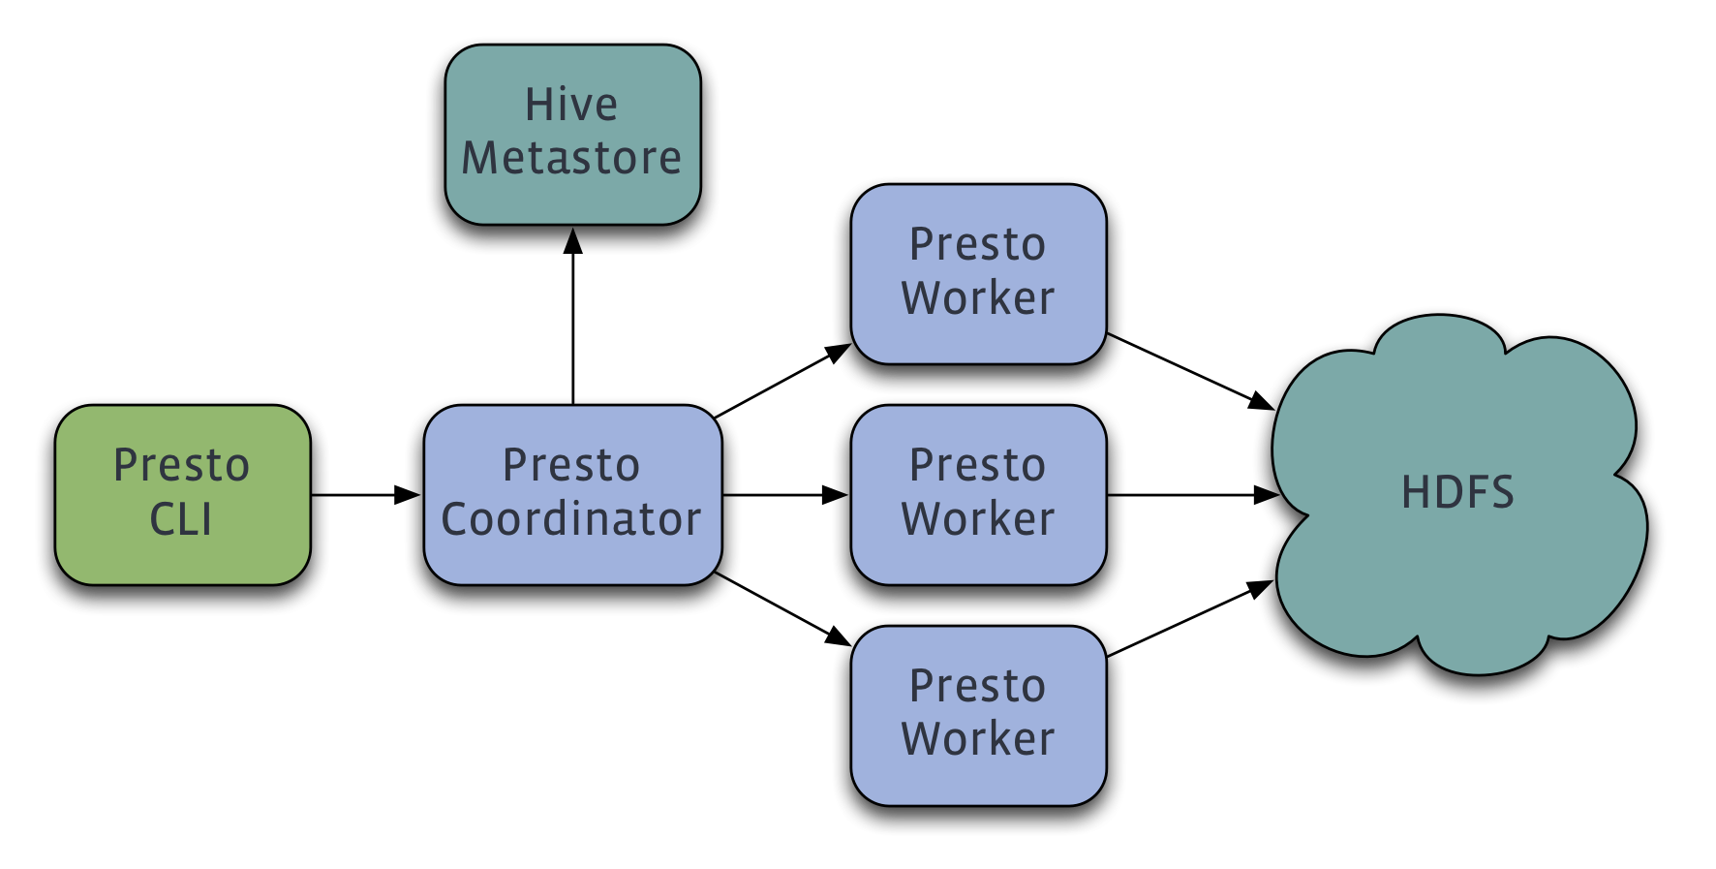

Like all architectures we have covered so far in this course, Presto operates similarly to other massively parallel processing (MPP) database management system (DBMS) architectures: on a cluster containing a single master (called **Coordinator)** and multiple slaves (called **Workers).**

The coordinator interacts with prestodb clients and it parses, analyzes and plans the query that is submitted by the Presto CLI (or any other client that interacts with PrestoDb). As part of this process, the coordinator interacts with **Connectors**, which are plugins that provide both metadata and data for execution of the query.

By “plugin”, we mean some code that defines how Presto can fetch data from an external data source, such as HDFS or AWS S3. The connector is responsible for providing information about the data schema (ie: the columns and datatypes) for the particular source. It also provides the location of the data and the data itself.

With presto, it is possible to define **custom** connectors for 3rd party data formats (S3 is a good example). Given this feature, Presto is just an **abstraction layer** over various data sources that leverages standard SQL as the common querying language of choice. This is really powerful as it basically means anyone who knows SQL can query large swaths of data from multiple sources, even if the sources themselves don’t support sql based querying.

In the diagram below, we can observe the an example of prestodb’s workflow model:

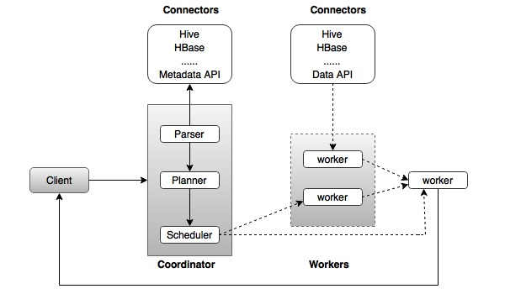

* First, a client submits a SQL query to the coordinator node.
* The coordinator parses the SQL, analyzes it and plans the SQL execution. As part of this process, it also invokes various connectors to pull in the metadata that describes how the data is formatted for each datasource. (These connectors must be registered with Presto prior to making sql queries, of course).
* Then, the scheduler submits jobs to the worker nodes, optimizing for workers that are idle and monitors worker health and worker progress in executing the query itself.
* The workers actually fetch the data via the connectors and aggregate results. Once completed, a worker node delivers the results back to the client.

## Defining ETL

Getting started with AWS Athena is very easy. By itself, S3 buckets store flat files that contain no additional information with regards to information schema or datatype. They are “flat” in that they are just text! Of course, S3 files can be and sometimes are stored in particular formats, such as CSV or JSON or parquet - but at the end of the day but themselves they are nothing special.

**ETL** refers to **E**xtract, **T**ransform, and **L**oad. An ETL process will take data (extract) - usually from a variety of sources and convert it into something more well defined and singular (transform). Finally, this transformed version of the data is loaded into a db or something that is optimized for querying. Usually, this is the version of the data that business intelligence teams interface with. Typically, loading happens incrementally, usually once an hour (or faster, depending on business need). This is usually configured and run on a schedule.

ETL can be hard and difficult to manage. This is where AWS Glue comes in.

## AWS Glue

Glue is a managed ETL service provided by AWS. By “managed service” we mean that AWS internally leverages other AWS features (EC2s, etc) to provision and run an ETL pipeline that can take input data and load it incrementally into a queryable format for us. Basically, you don’t have to think about or spin up any infrastructure elements in order to get your pipeline running. Just tell Glue where the data lives and optionally, what the schema is for the data.

### Glue Data Catalog

The Glue Data Catalog defines metadata for your data. It contains information such as table definitions and other control information to manage your Glue account itself. By **table definition**, we mean the data’s schema - is your data stored in CSV format? If so, what are the datatypes of the columns (numbers? Strings? Dates? etc). Is your data stored in JSON format? If so, what are the fields called.

For our purposes, we will be using primarily S3 as our data source. In S3, we usually equate the top level **S3** bucket to a **database**. The subfolders which contain the files themselves are **tables**. We define schemas for the files in the S3 subfolders. **NOTE**: the data itself still lives in S3 (as per this example). The Glue Data Catalog only stores the *schema*, which is the columns list and columns data type definitions (and a few other elements). This provides other programs a way to understand and infer the data which is still living at the data source level.

We can define the table definitions (basically the schema) ourselves or we can ask glue to infer it for us. For well defined data formats (like JSON), glue is pretty good at reading and understanding what the data types and data fields are.

### Classifiers

A classifier is some code that determines the schema of our data. For common data formats (as mentioned above, common examples are CSV or JSON - *or* things like Parquet or XML), Glue already has built in classifiers. We can also specify or write our own classifiers if needed.

### Crawlers

A Glue Crawler is a program that connects to our datastore, determines the classifier for the dataset, and then generates metadata tables defining our data schema in the Glue Data Catalog. This schema can then be read by other services or programs, such as AWS Athena, to determine how to interactively query our underlying dataset.

### Glue Architecture

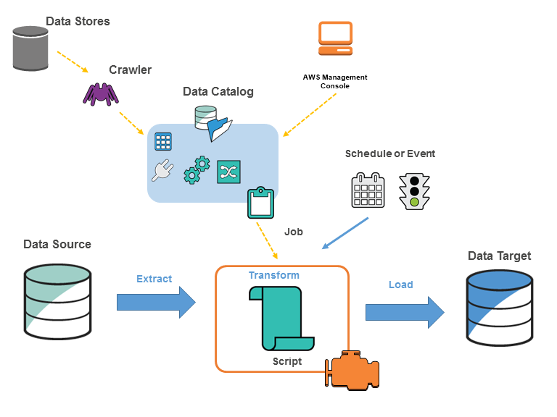

Using Glue, we can schedule and run **Jobs** that will actually perform the ETL using the Data Catalog as a “guide” for how to transform the data. Jobs can be scheduled on a trigger or ad-hoc. Typically a Job will use the Data Catalog to interpret the schema for the Data source, then it will load data from that source and apply a **transformation function** to convert it into a different format. This format will then be written by the job to the Data target.

For our purposes, we will not be leveraging the Job or ETL features of Glue but instead focus on the Data Catalog, which Athena will use to interpret and understand the schema of the S3 data we want to query. Also, we will use Glue to connect to Athena via Jupyter Notebook to run queries and interact with python code.

First, we begin by provisioning a basic “cluster” - a single master node and two worker nodes in EMR. This will provide us with the hardware necessary to run our Spark jobs.

## Querying S3 with Athena and Glue

We will now look at an example where we configure our Yelp dataset to be cataloged by Glue crawlers so that we can run interactive queries on it with Athena. To do so, we must:

* Set up Glue to leverage the JSON classifier to generate a table schema for our yelp dataset
* Point Athena to our Glue catalog as a Connector
* Run queries in Athena’s interactive querying shell to assert that we are indeed able to connect to and run queries against our S3 data

### Pricing

A note about pricing: **Athena is not part of the free tier**. That being said, Athena costs **$5.00/Terabyte** of data scanned. Additionally, queries that are cancelled and queries that are describe-type queries do not count.

For **Glue,** you only pay for the time it takes for a job to run. SInce we are not going to be leveraging this feature, Glue is for better or worse free for us.

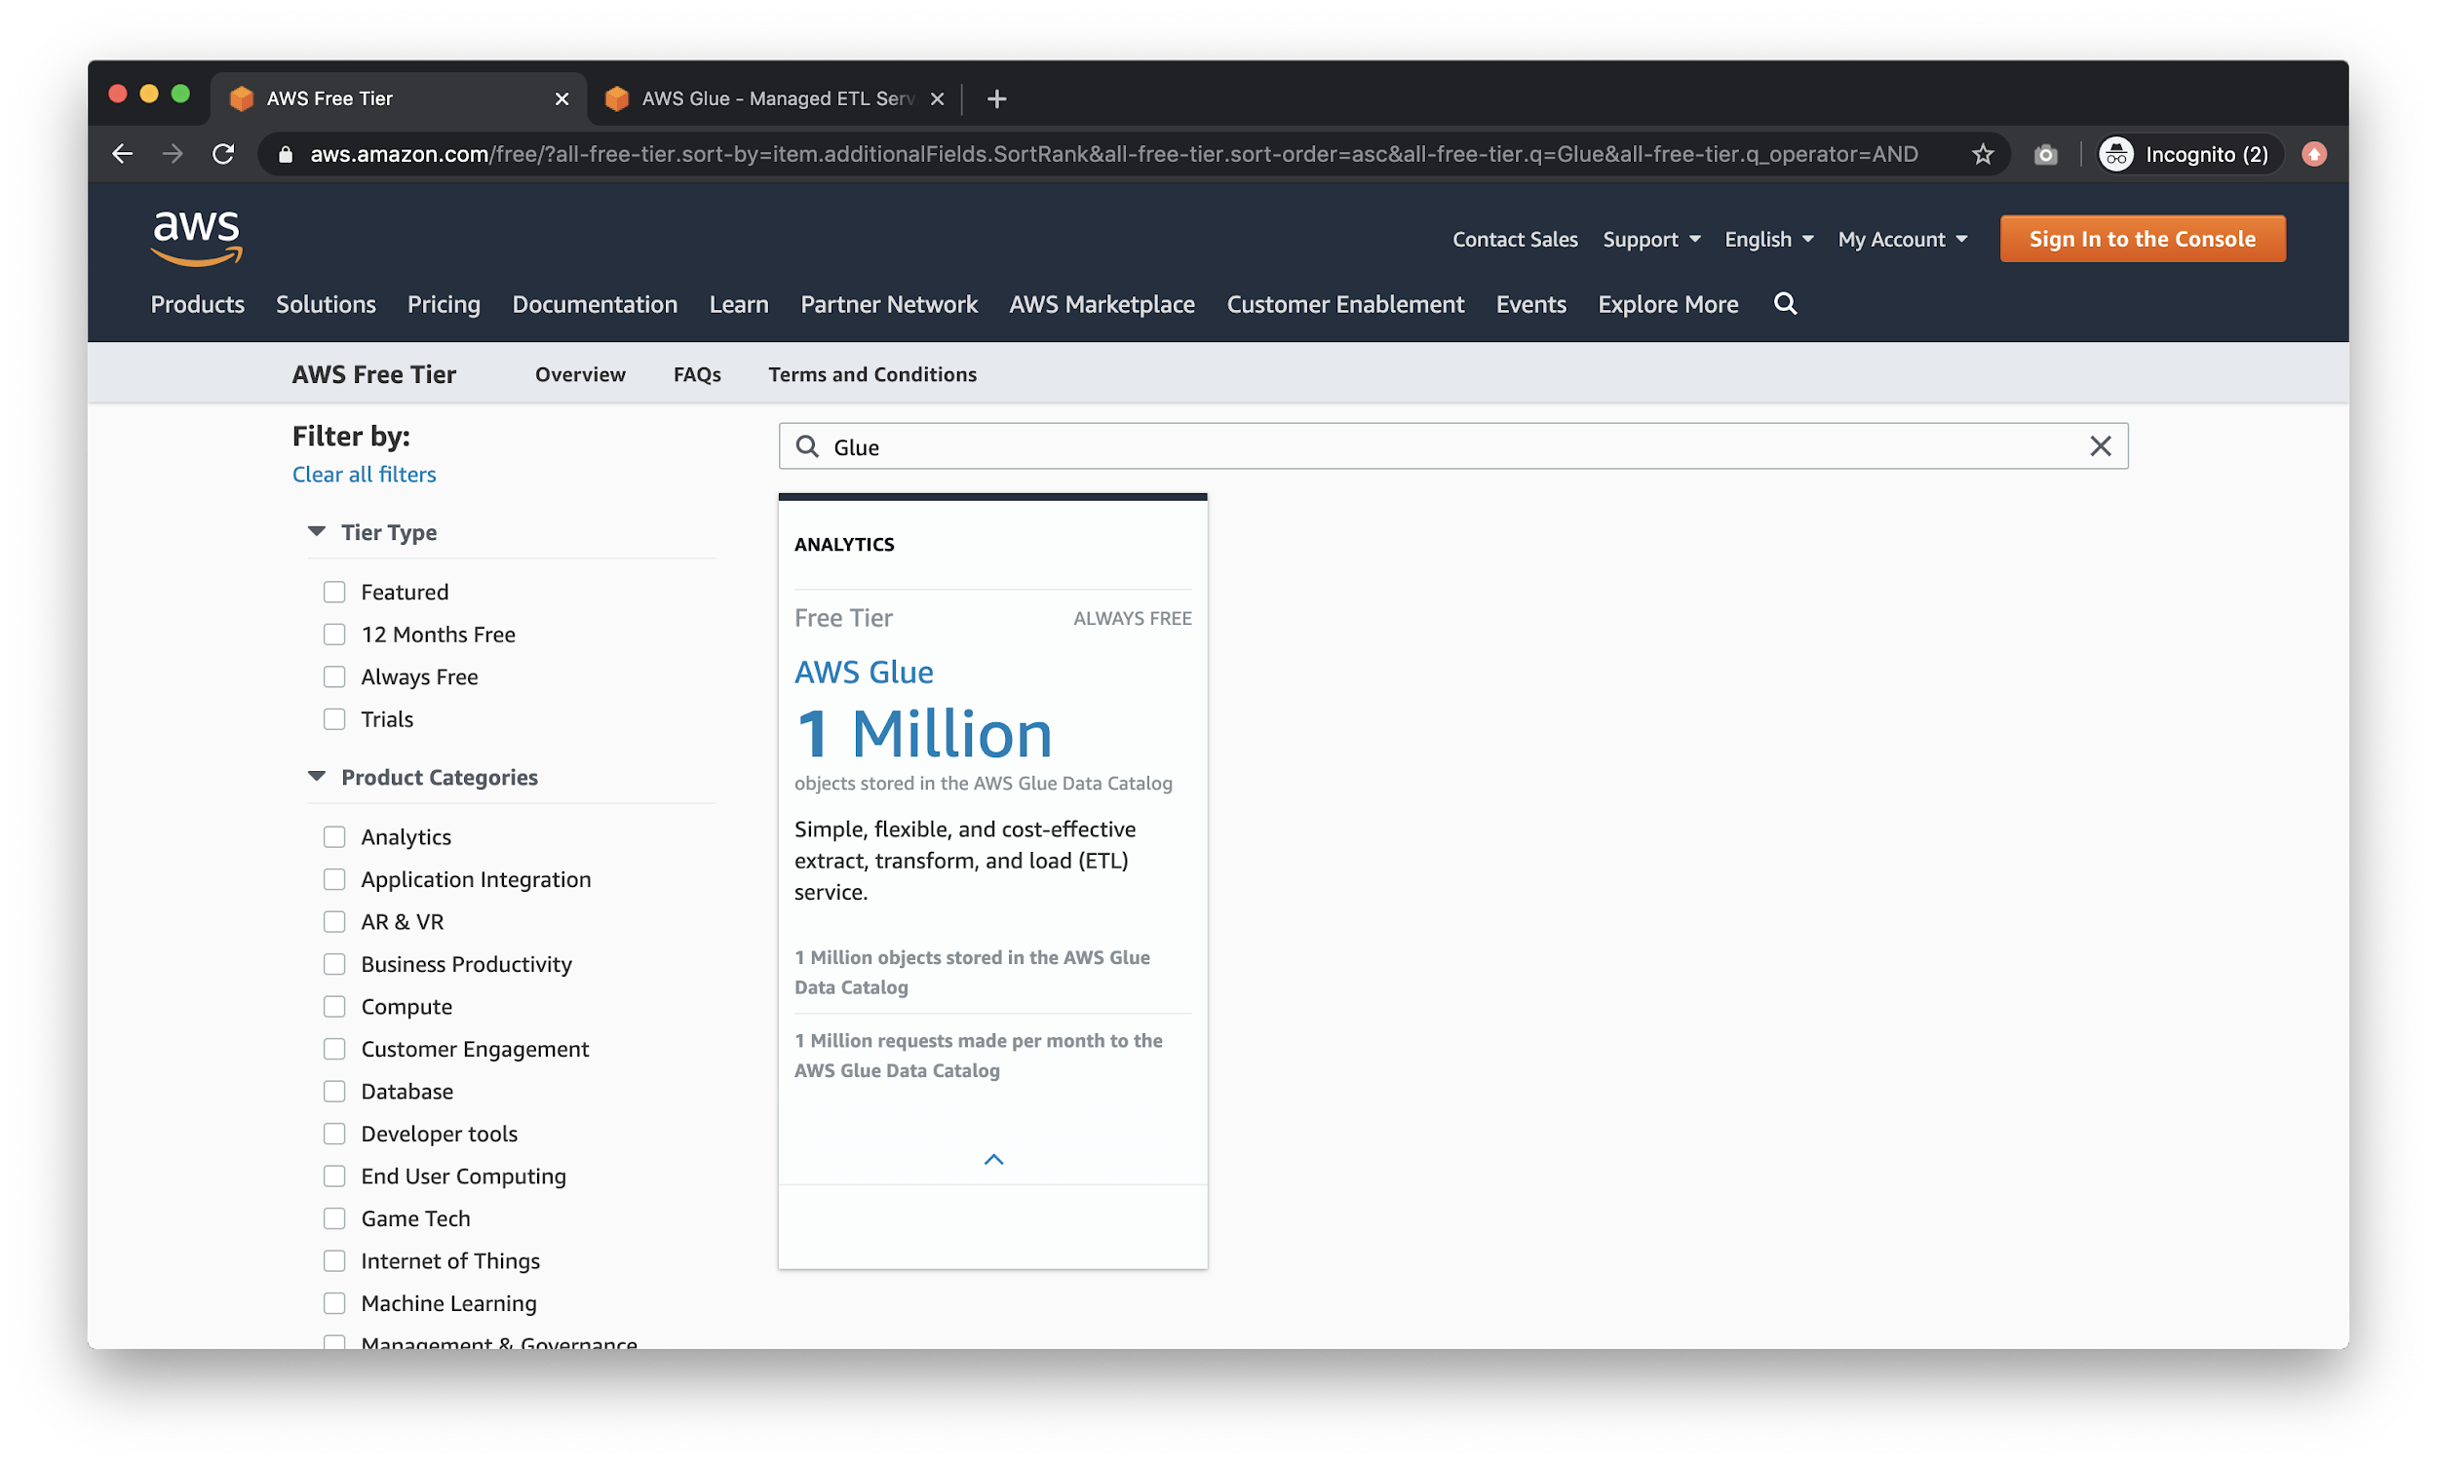

# Querying Yelp Data on S3 with Athena

Let’s now go over the steps required to set up and run a simple query via Athena. First, open up your AWS Console and type in “Athena”.

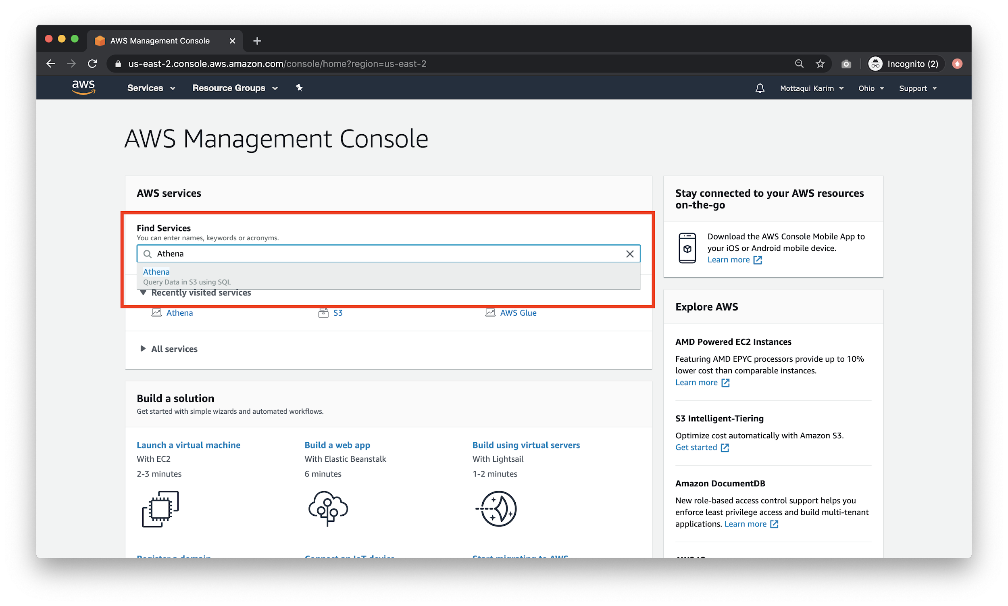

## Setting Up S3 Bucket for Athena

Because this is your first time using Athena, you will have to create an S3 bucket to hold your athena data.

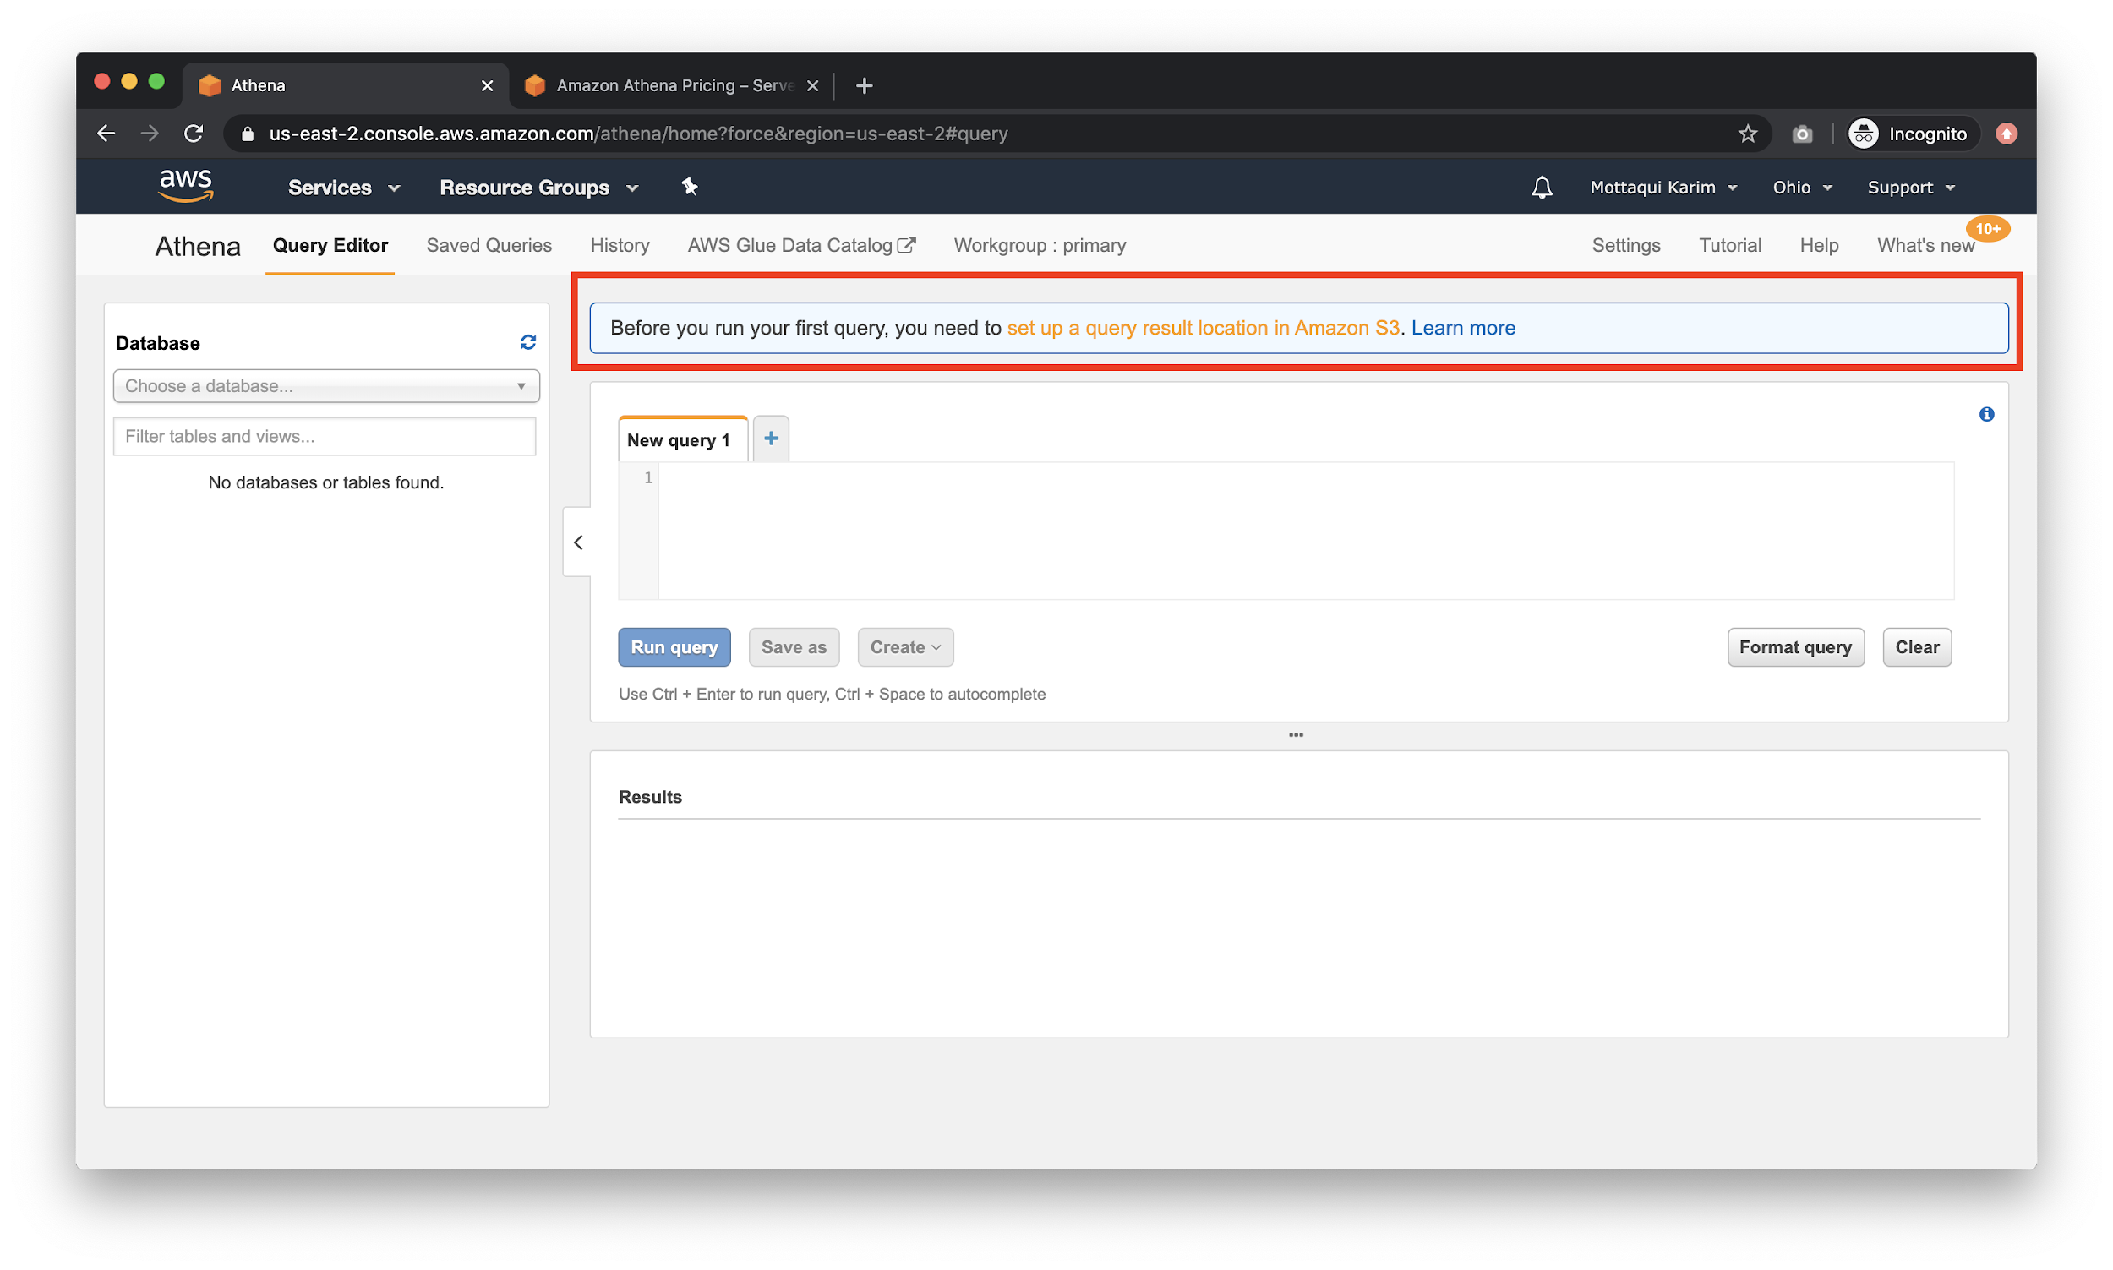

Click on the blue banner to open up the settings dialog. 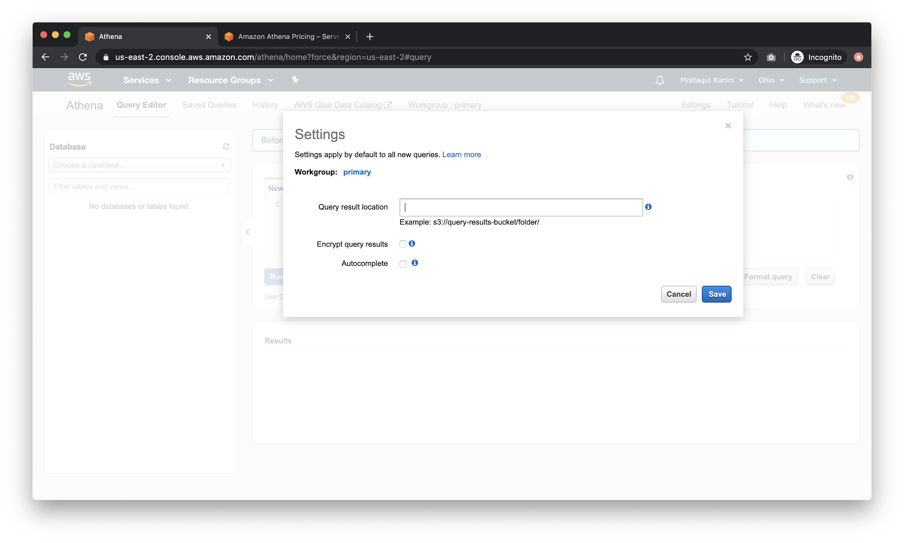

Now, **in a new tab**, open up AWS Console again and type in S3.

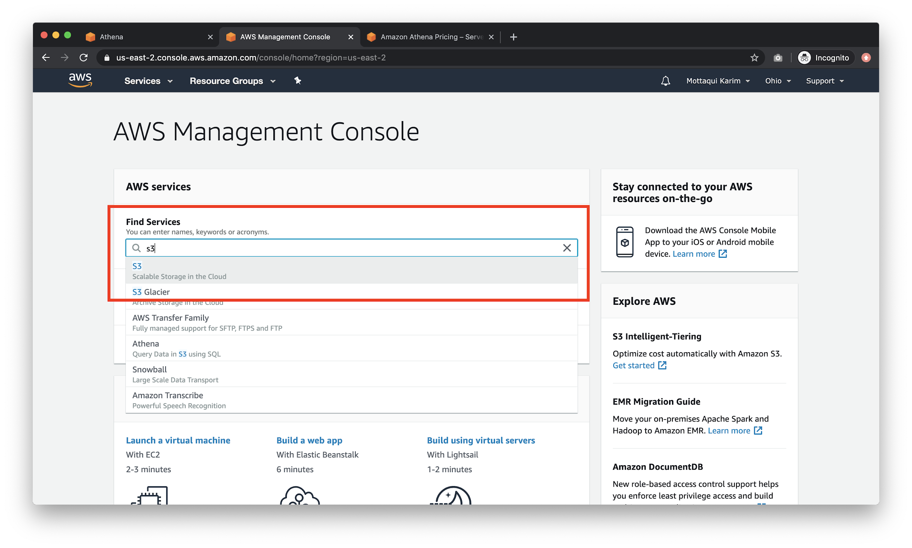

Create a new bucket.

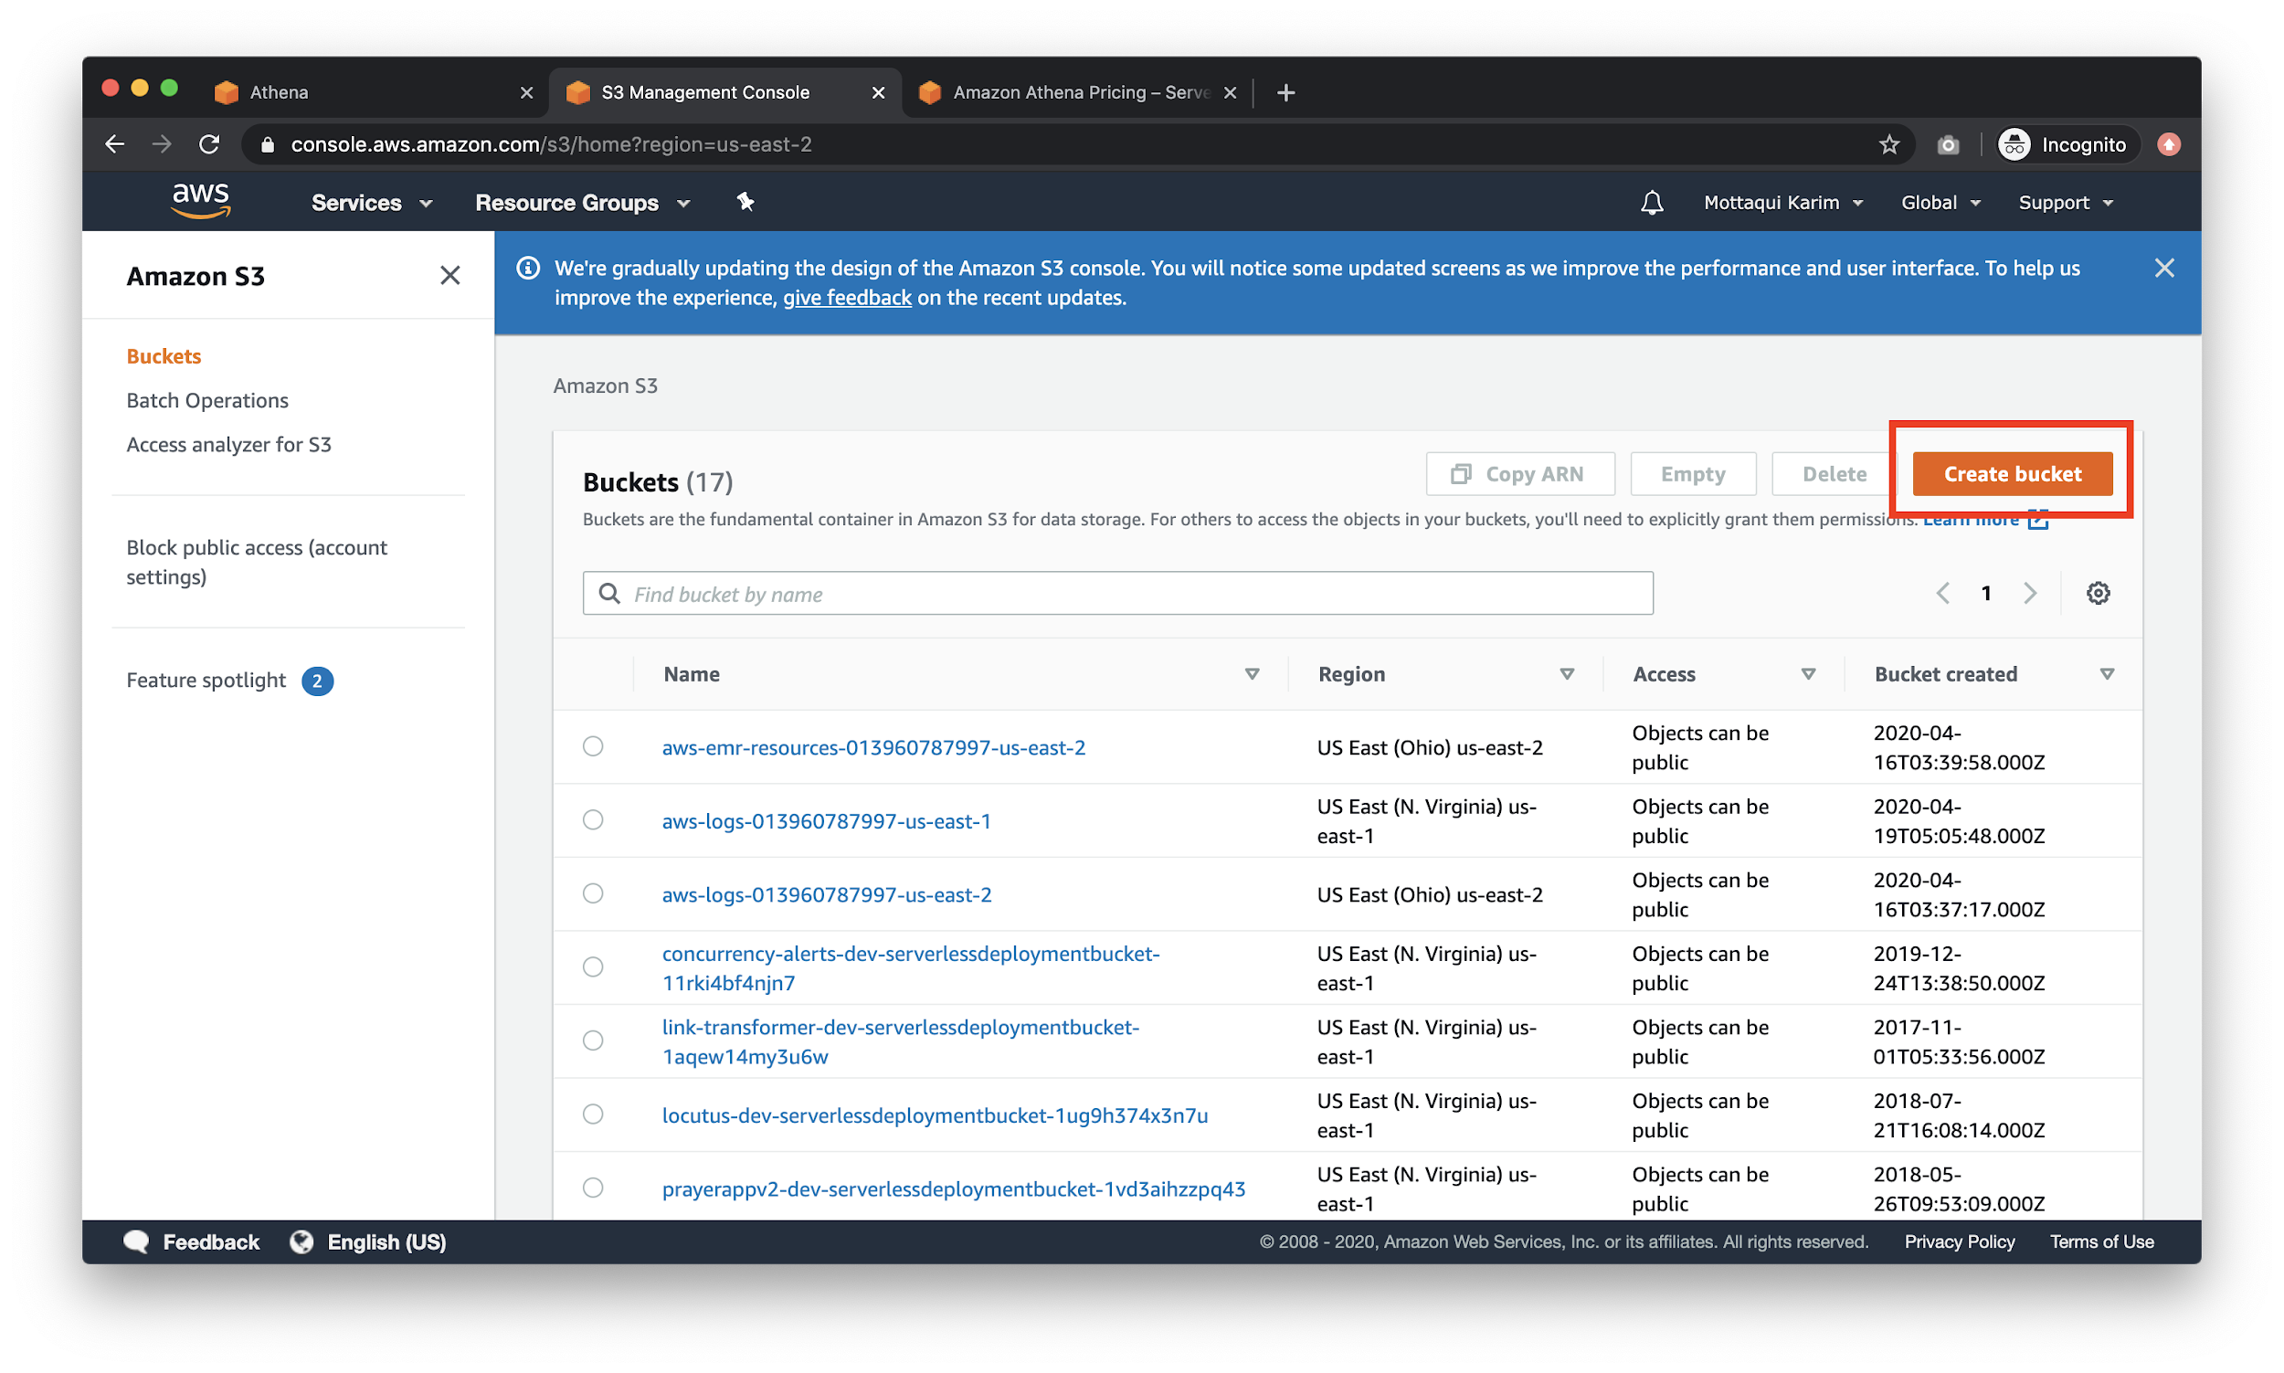

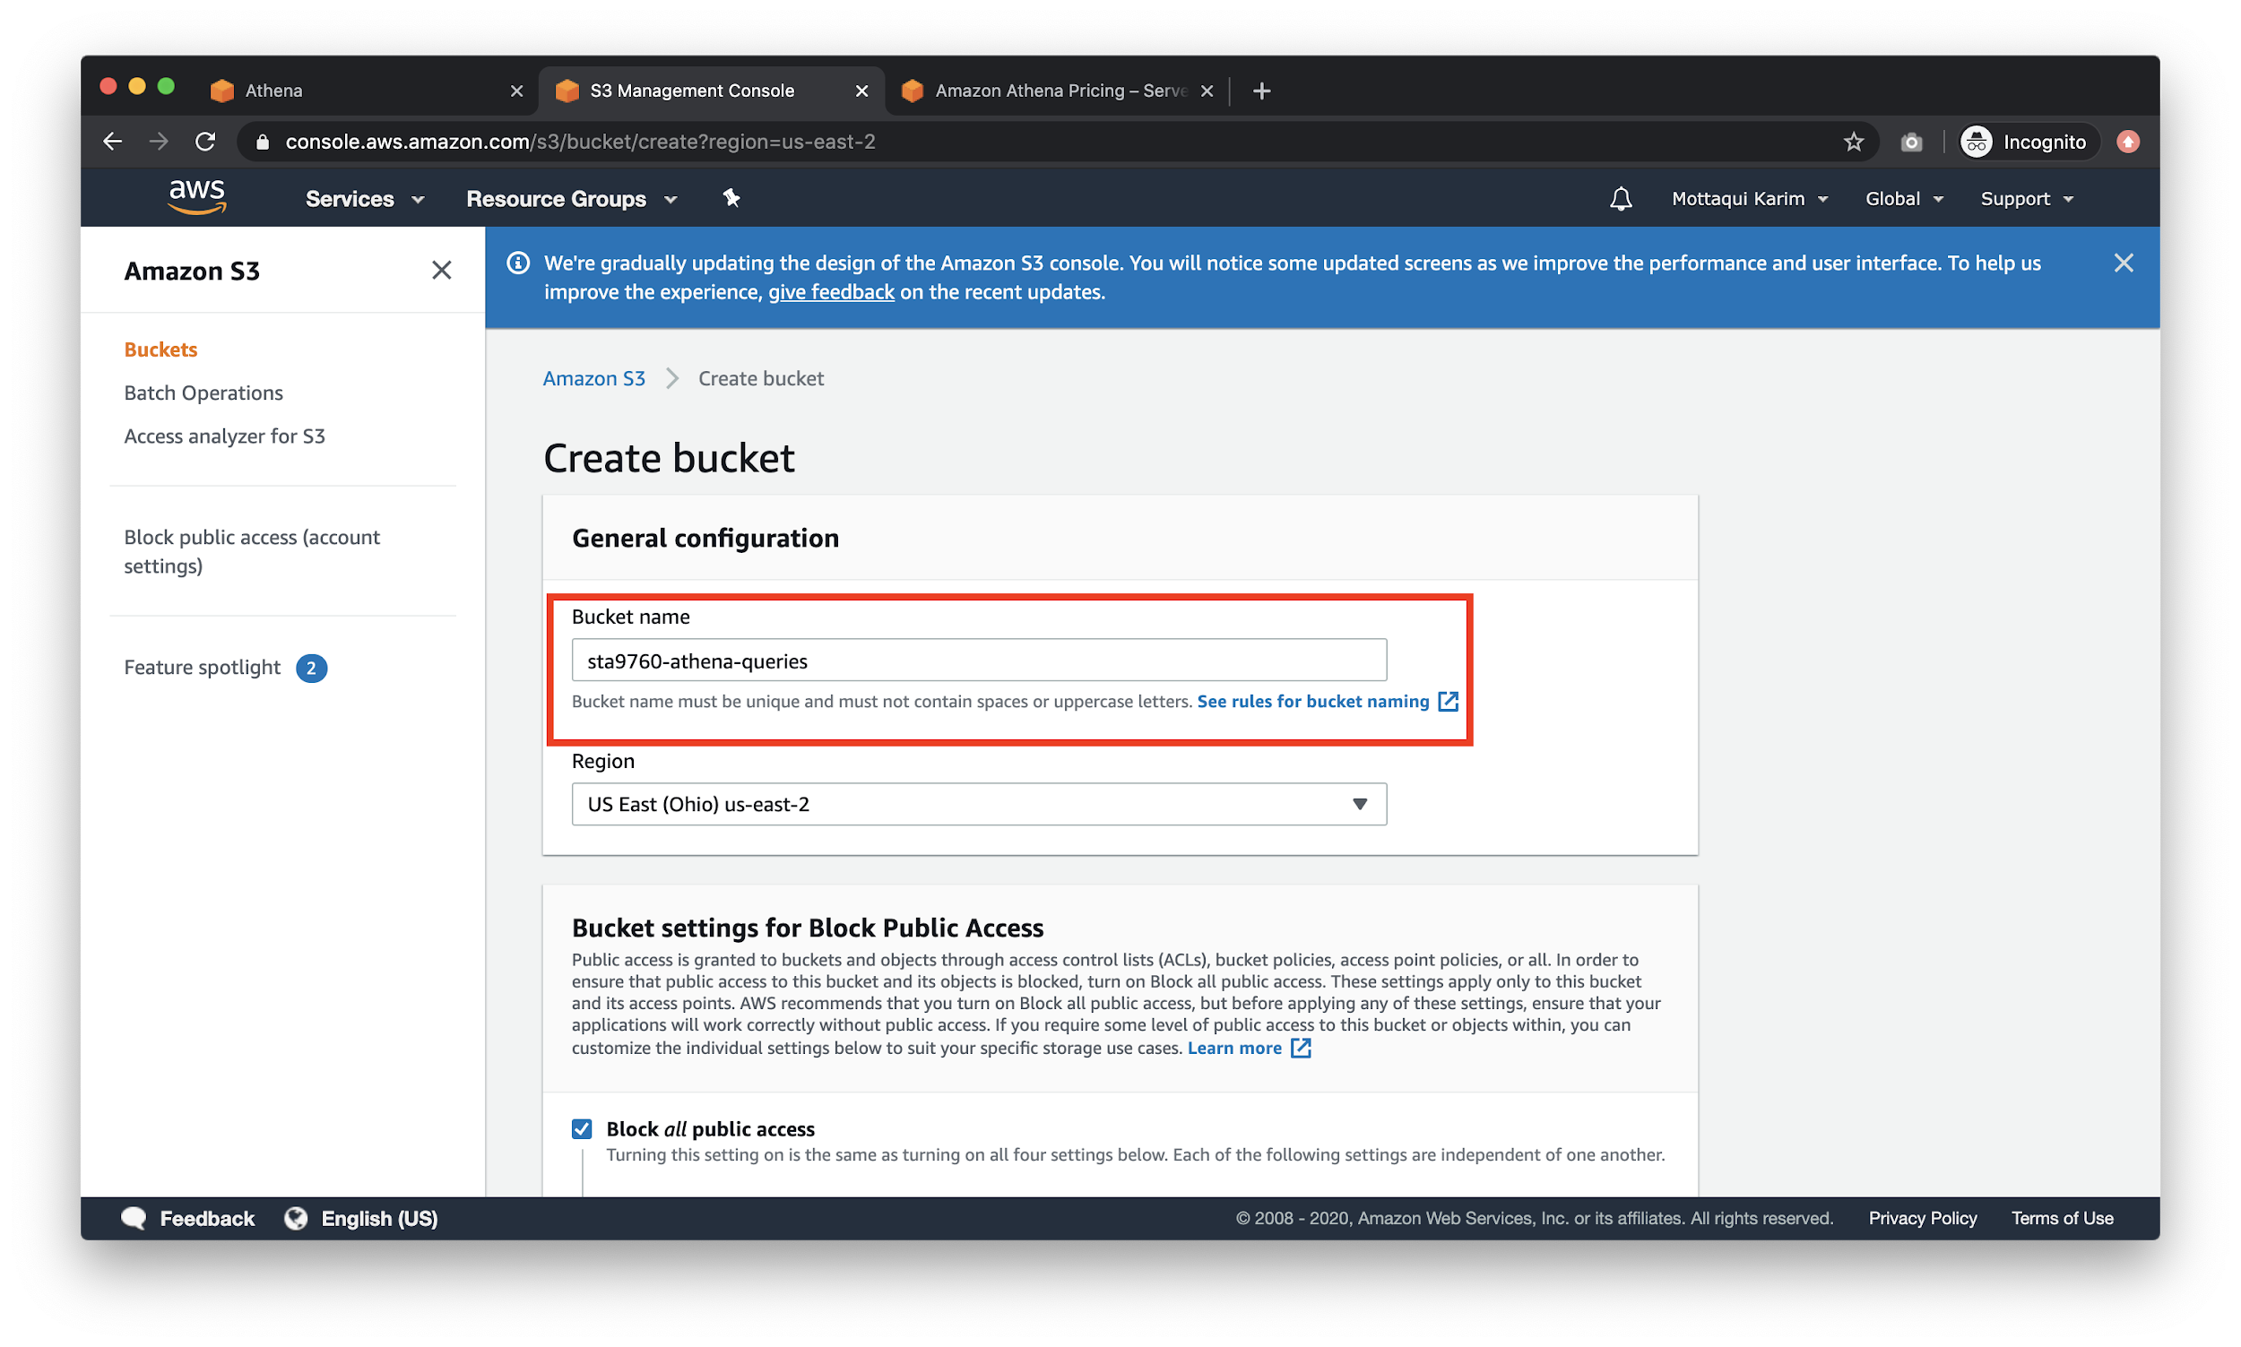

Then, create a folder **within** this bucket.

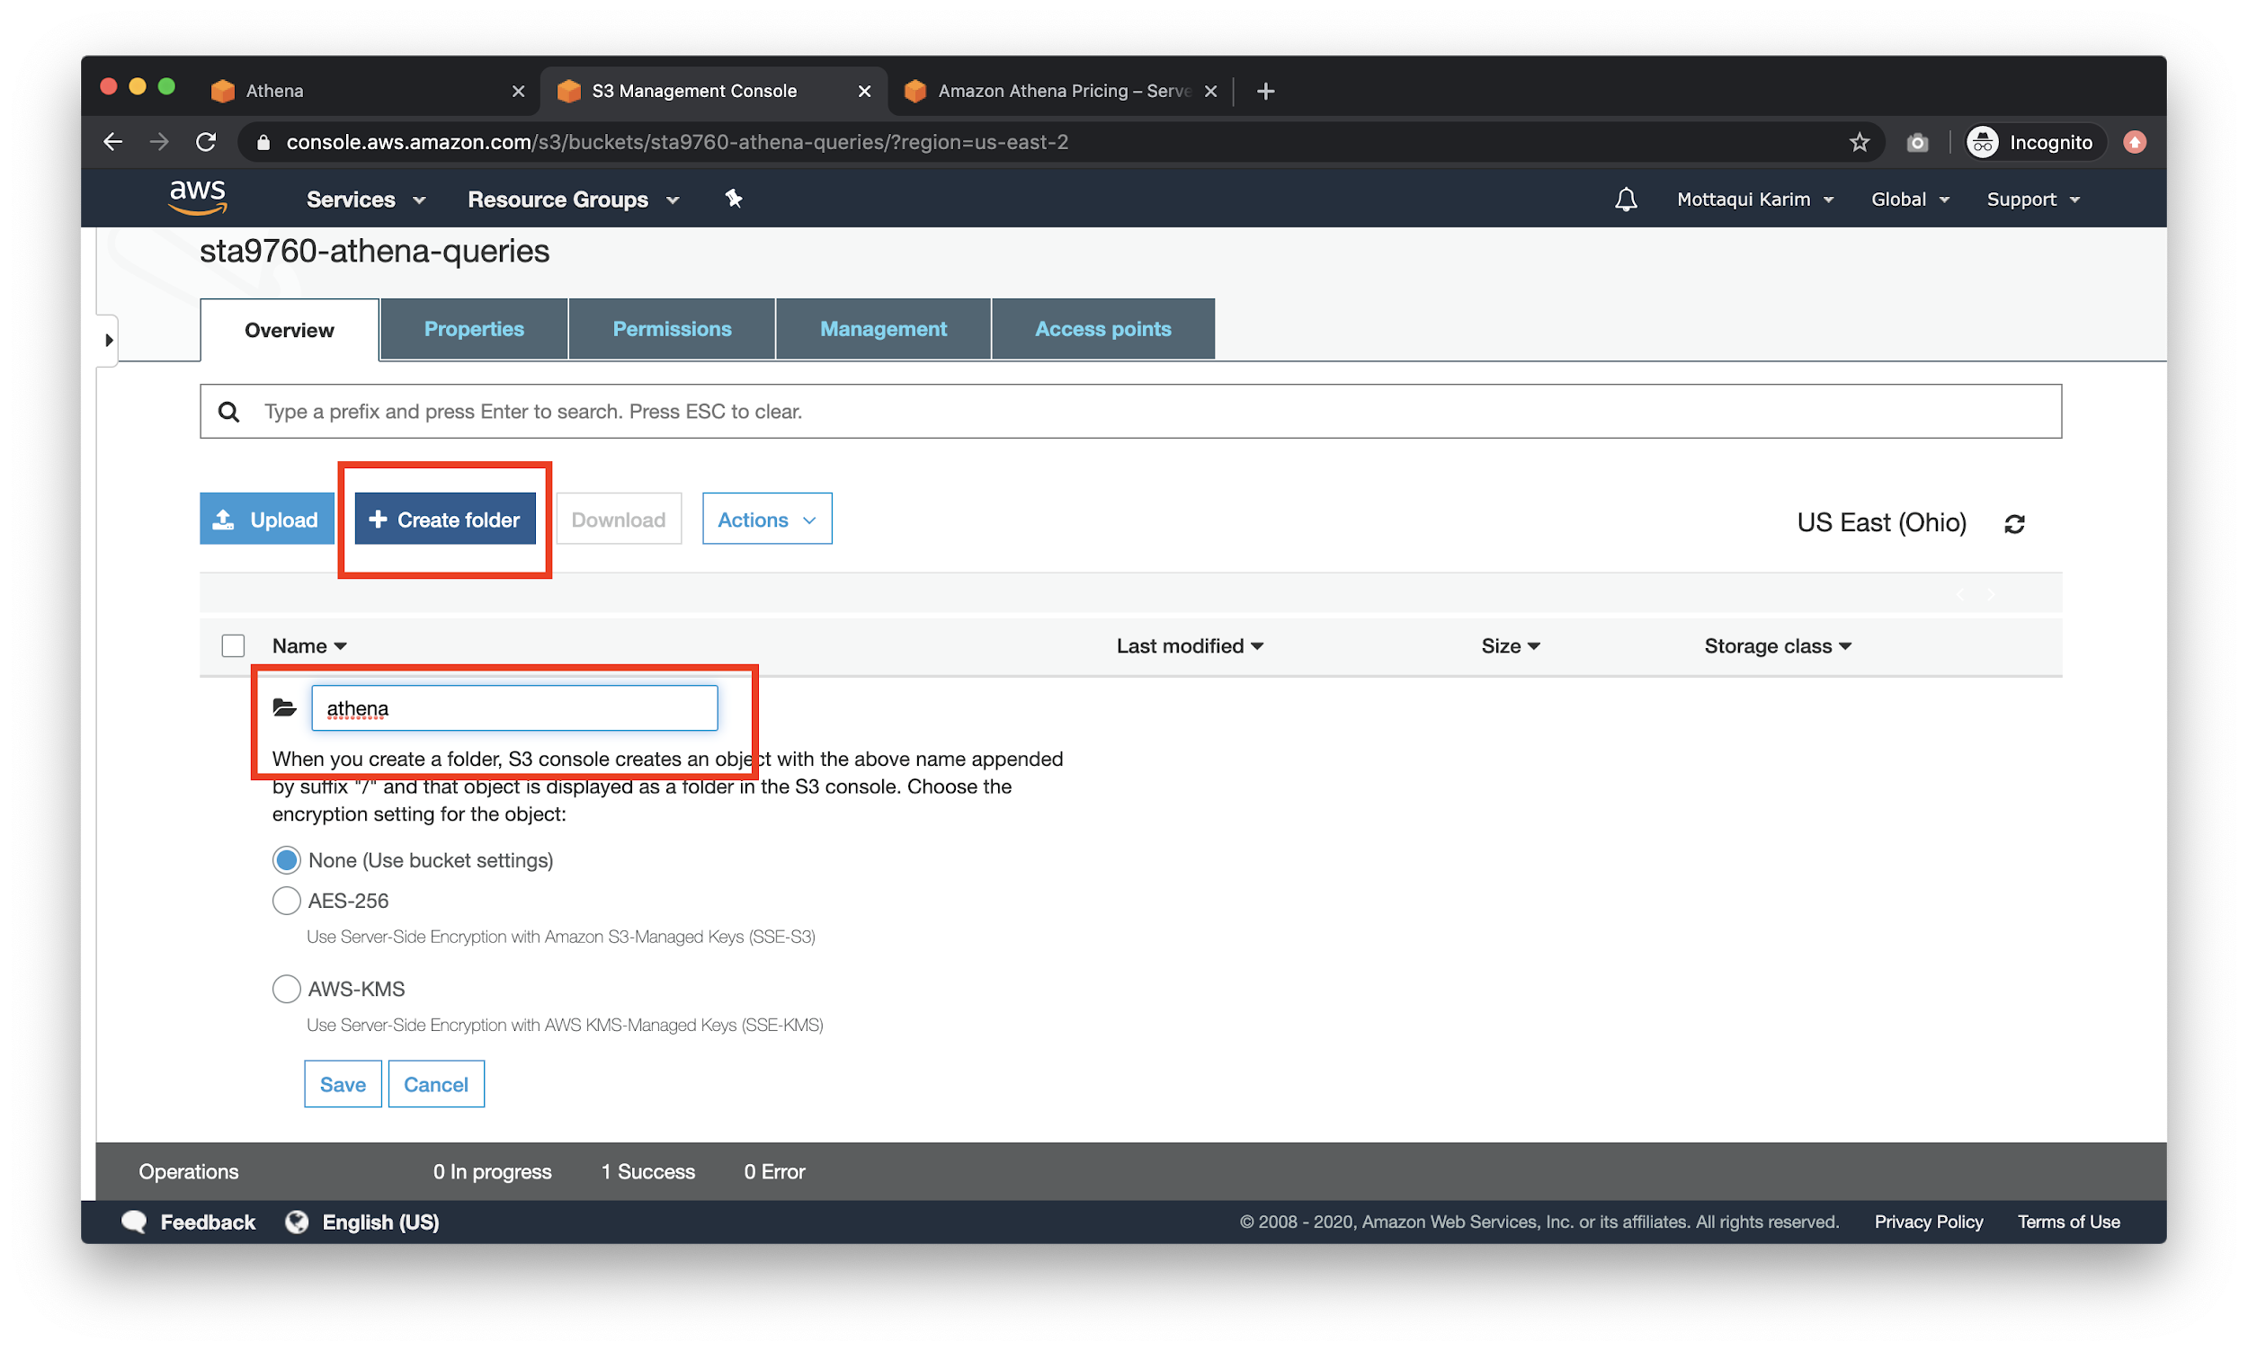

Finally, go back to your Athena tab so that you can fill out the **query result location** field with the location of the S3 bucket that you just created.

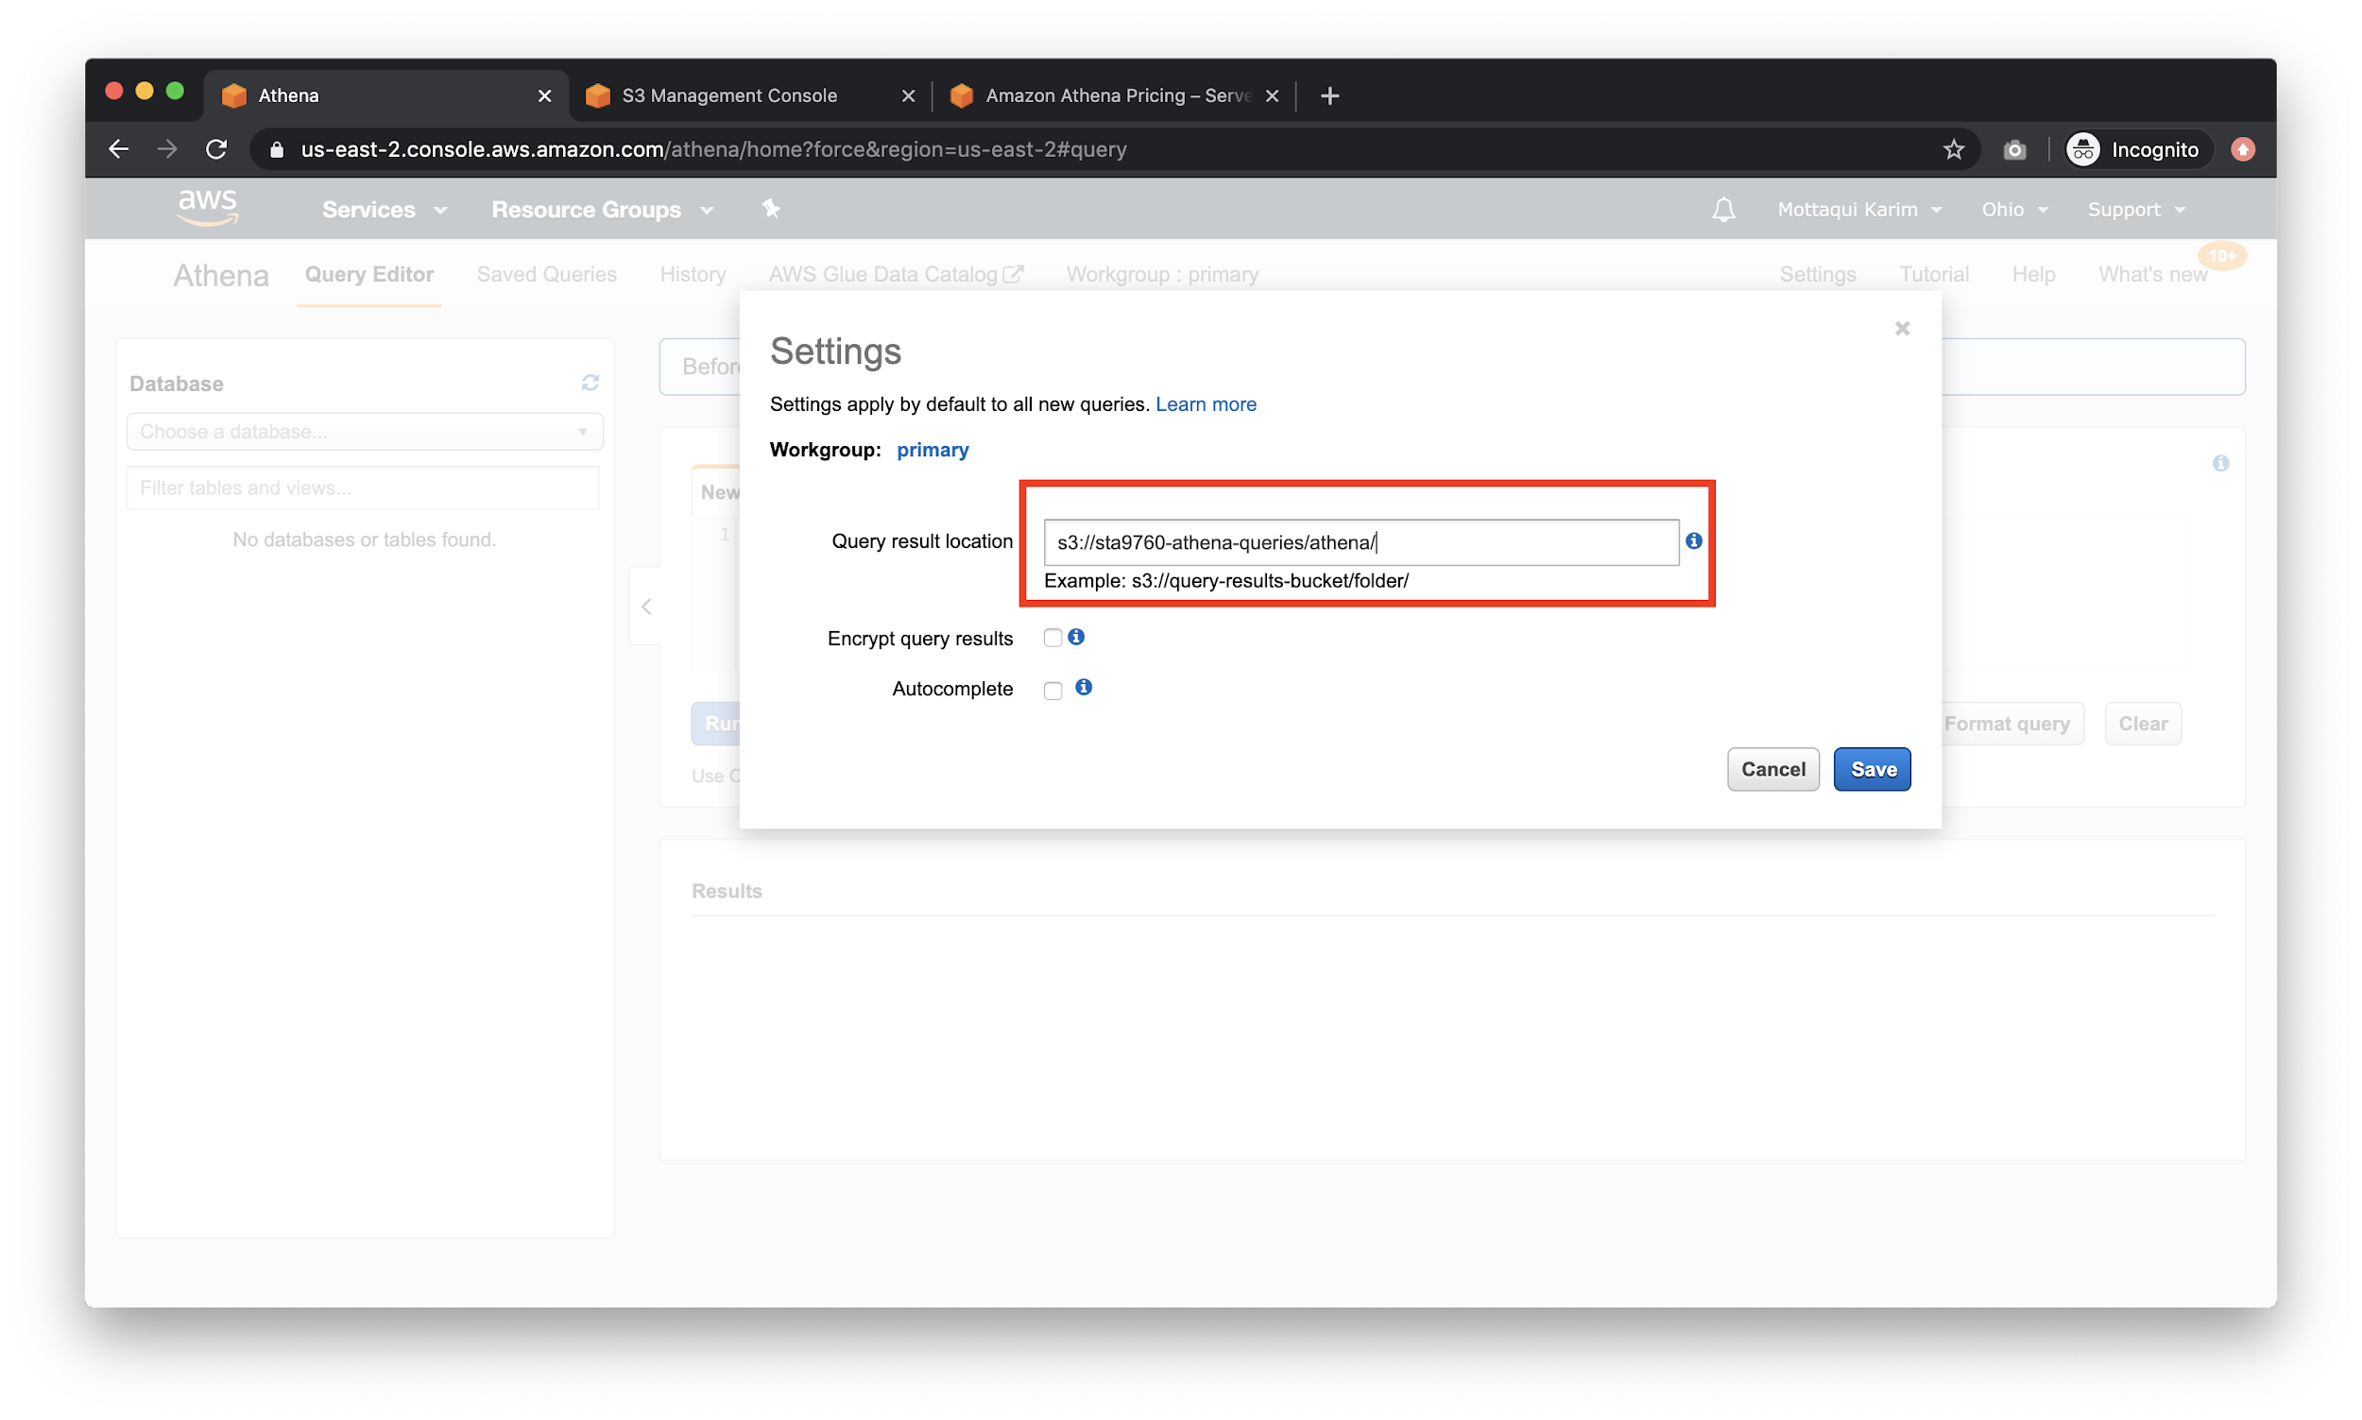

Hit **Save** and then go back to AWS Console and type in **Glue**.

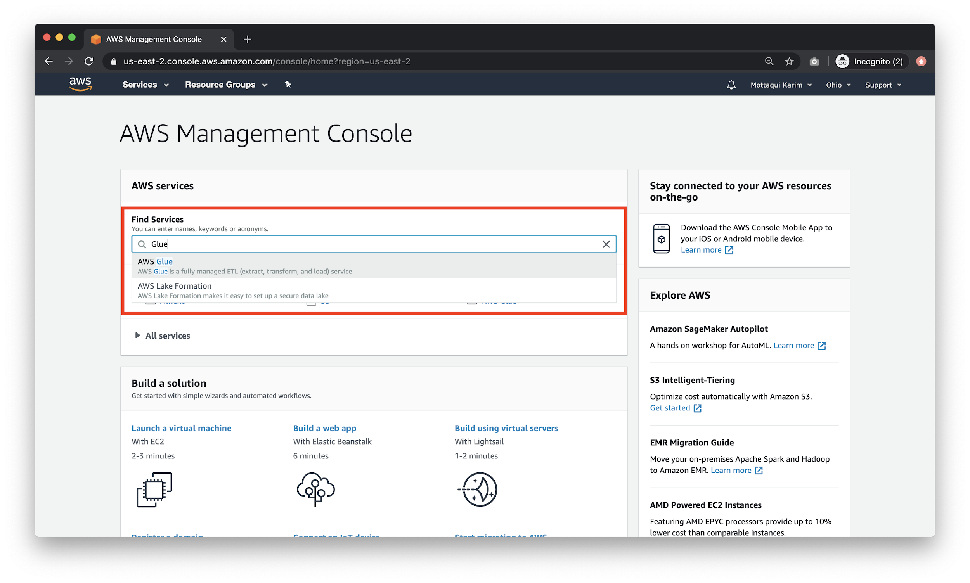

## Configuring Glue Crawler

You should end up on this landing page:

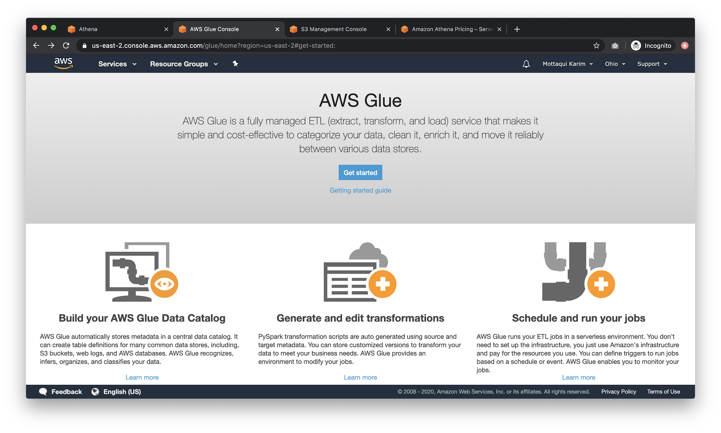

Hit **Get Started** and navigate to this page: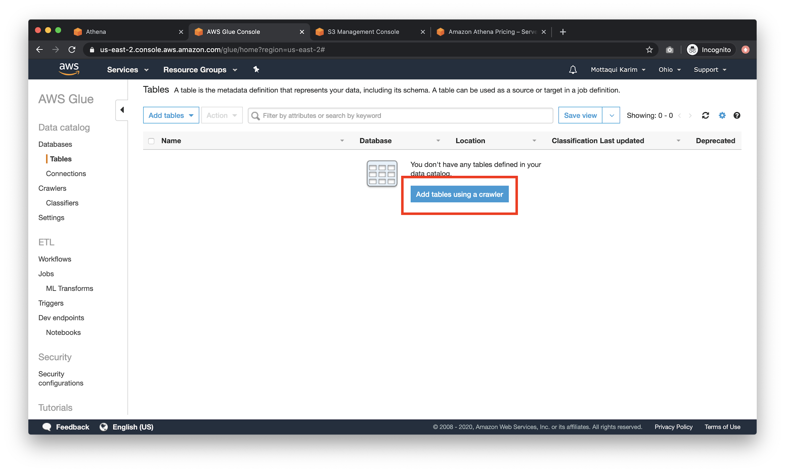

Click on **Add tables using a crawler** to get started on your first Glue table!

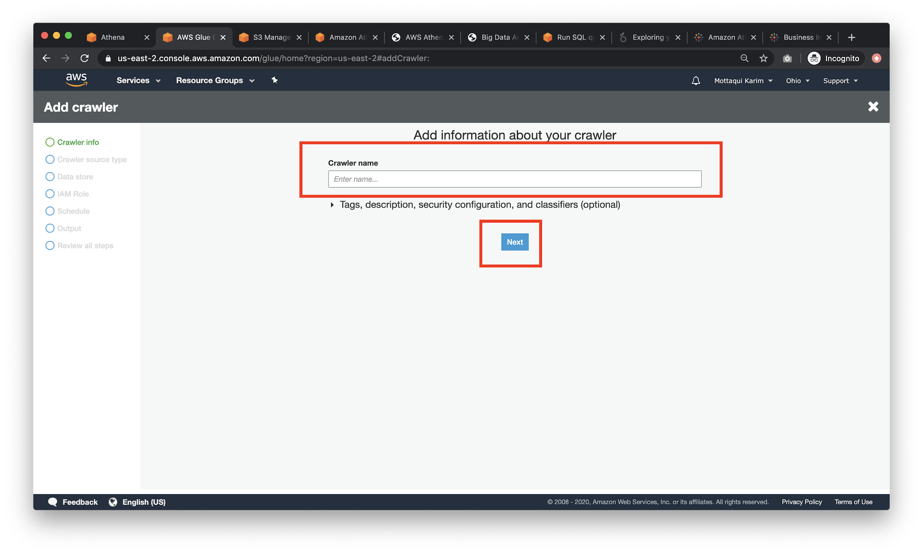

Specify a reasonable name without any spaces or punctuation before continuing. For **crawler type**, pick **Data stores**

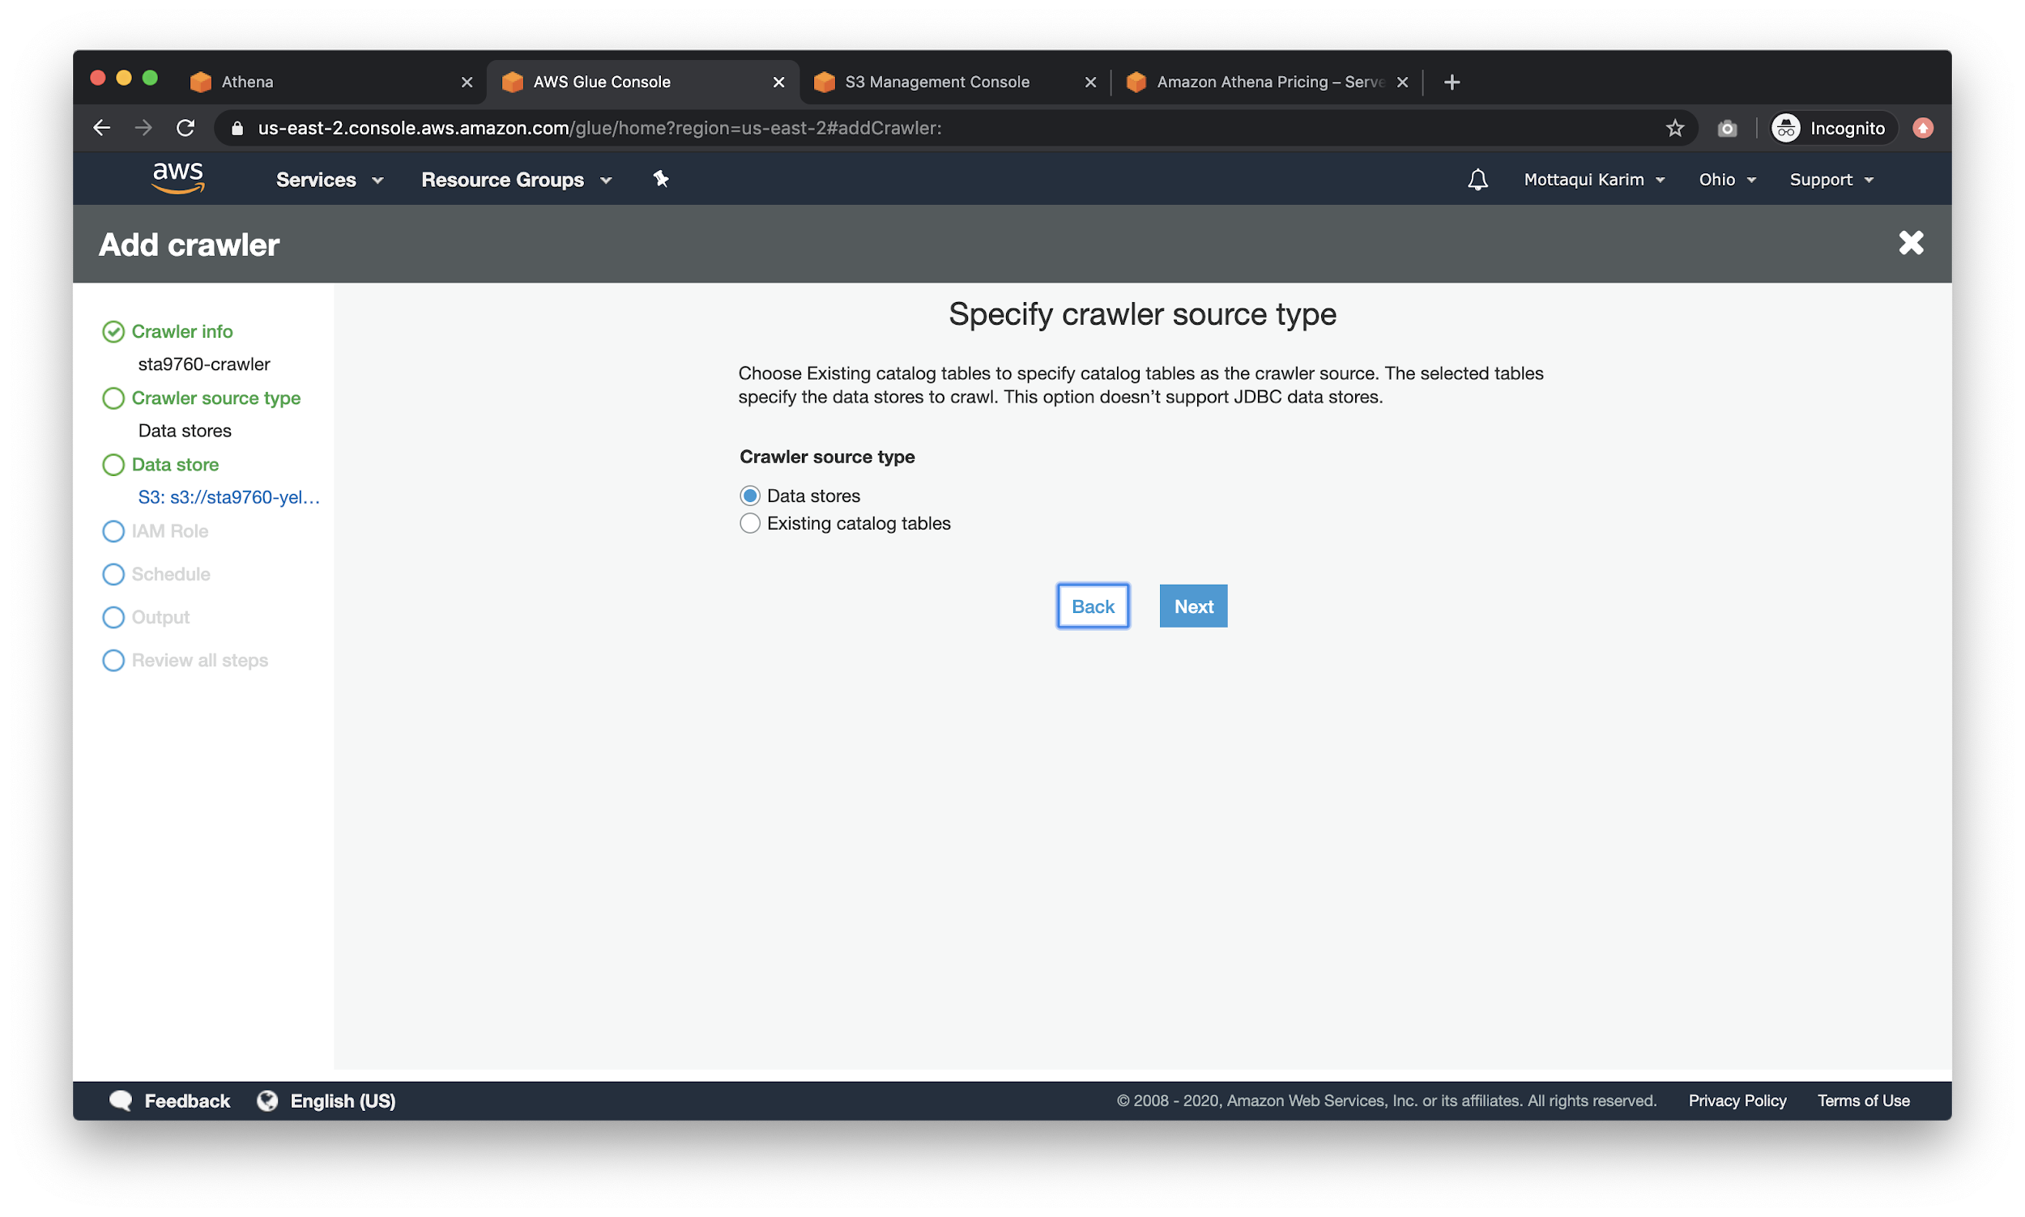

In the next screen, choose **S3** for the data store and **point to your S3 bucket** “yelp” subfolder (or whatever it is you called it).

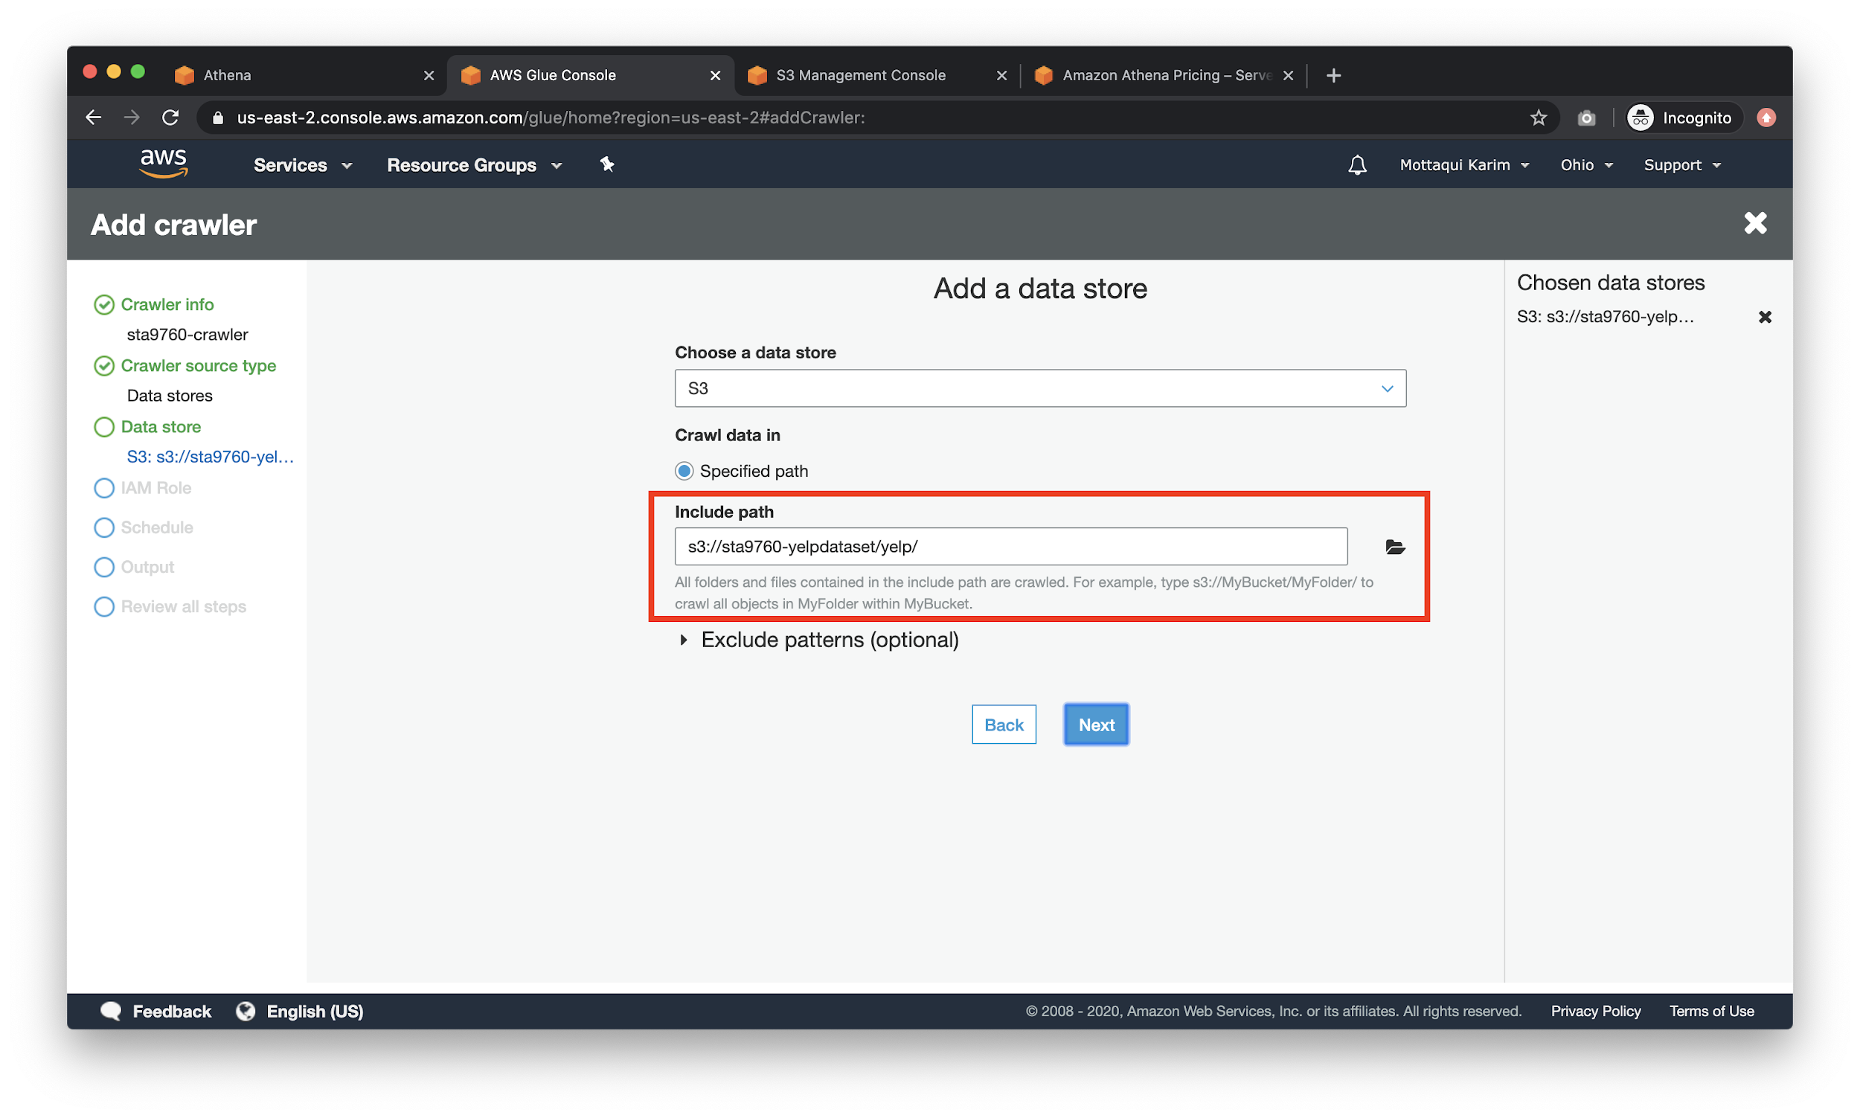

For now, pick **No** on the **Add another data store** screen.

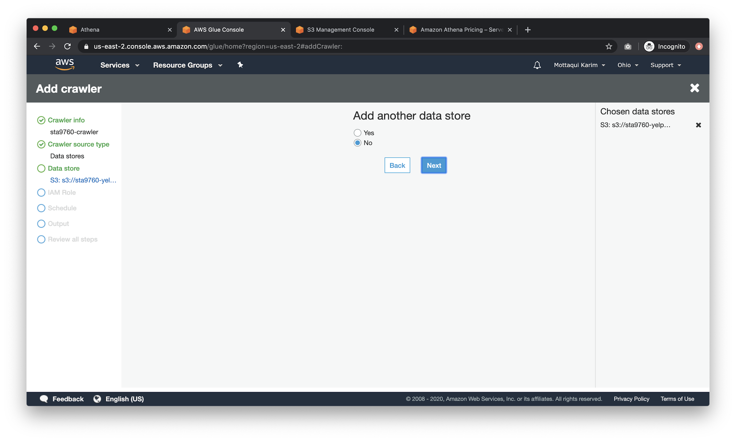

An **IAM** role is how AWS manages permissioning across services. For our purposes, **Create an IAM role** so that AWS can automatically apply the correct permissions needed for the Athena and Glue and S3 services to talk to each other.

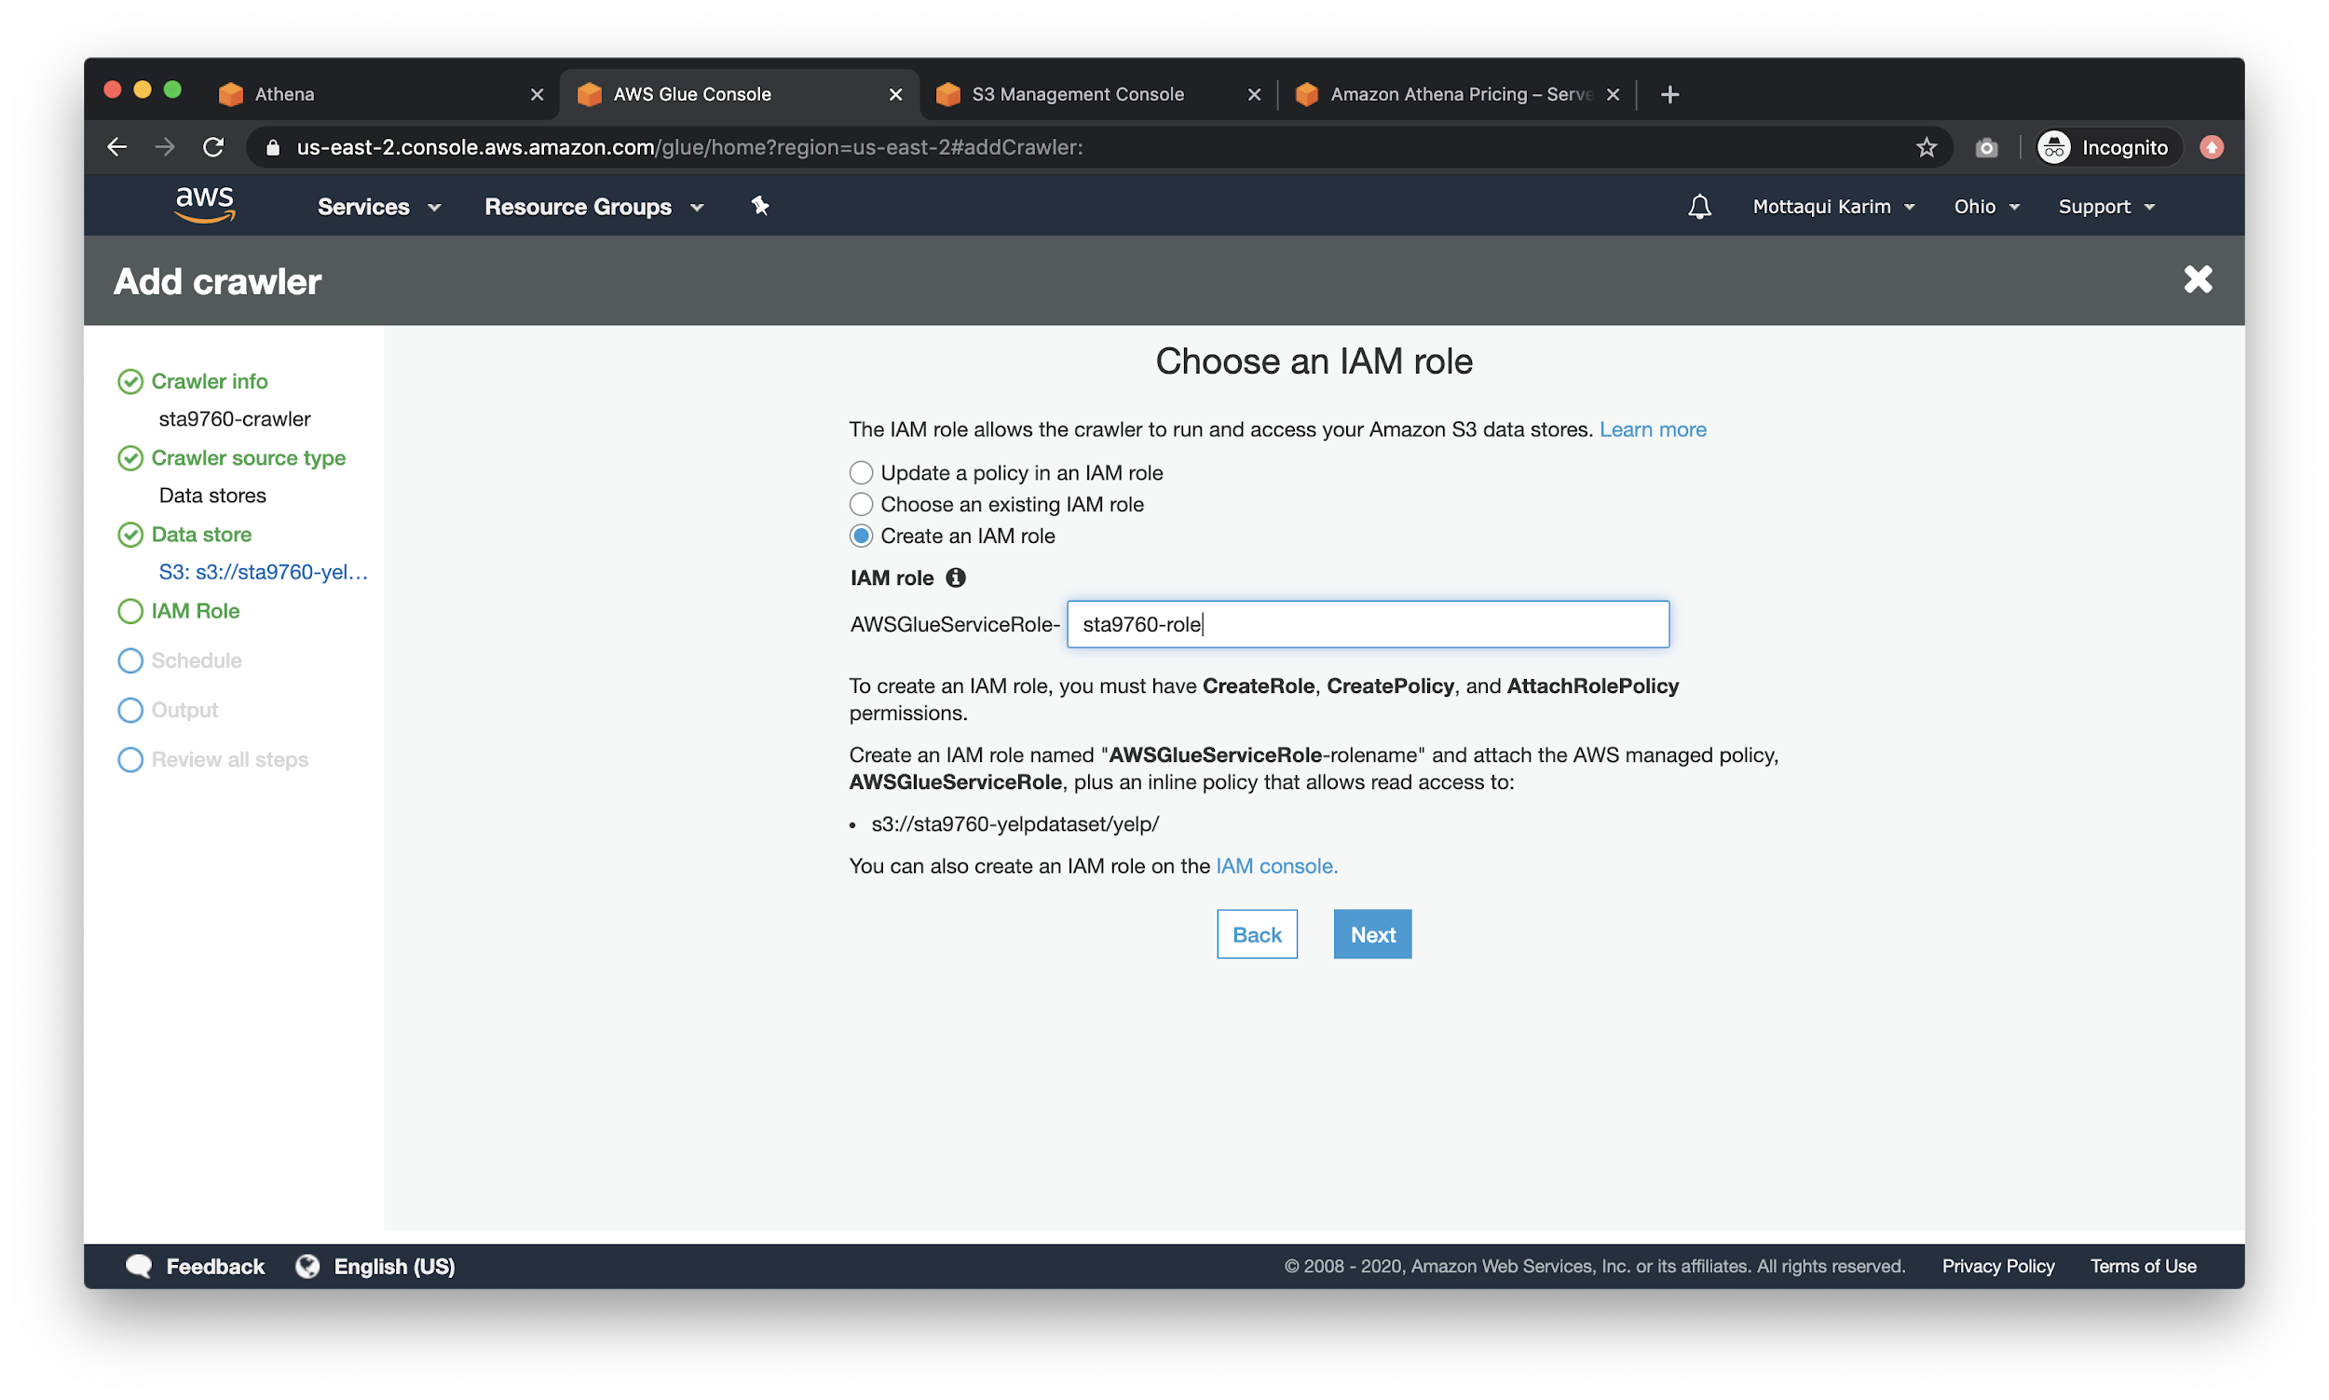

~~For the frequency of the crawls (on the next screen), choose the most coarse option possible. I picked~~ **~~hourly~~** ~~but that is largely unnecessary.~~  **NOTE: CHOOSE “Run on demand” OPTION. Otherwise, you will be billed - cheaply, but billed nonetheless.**

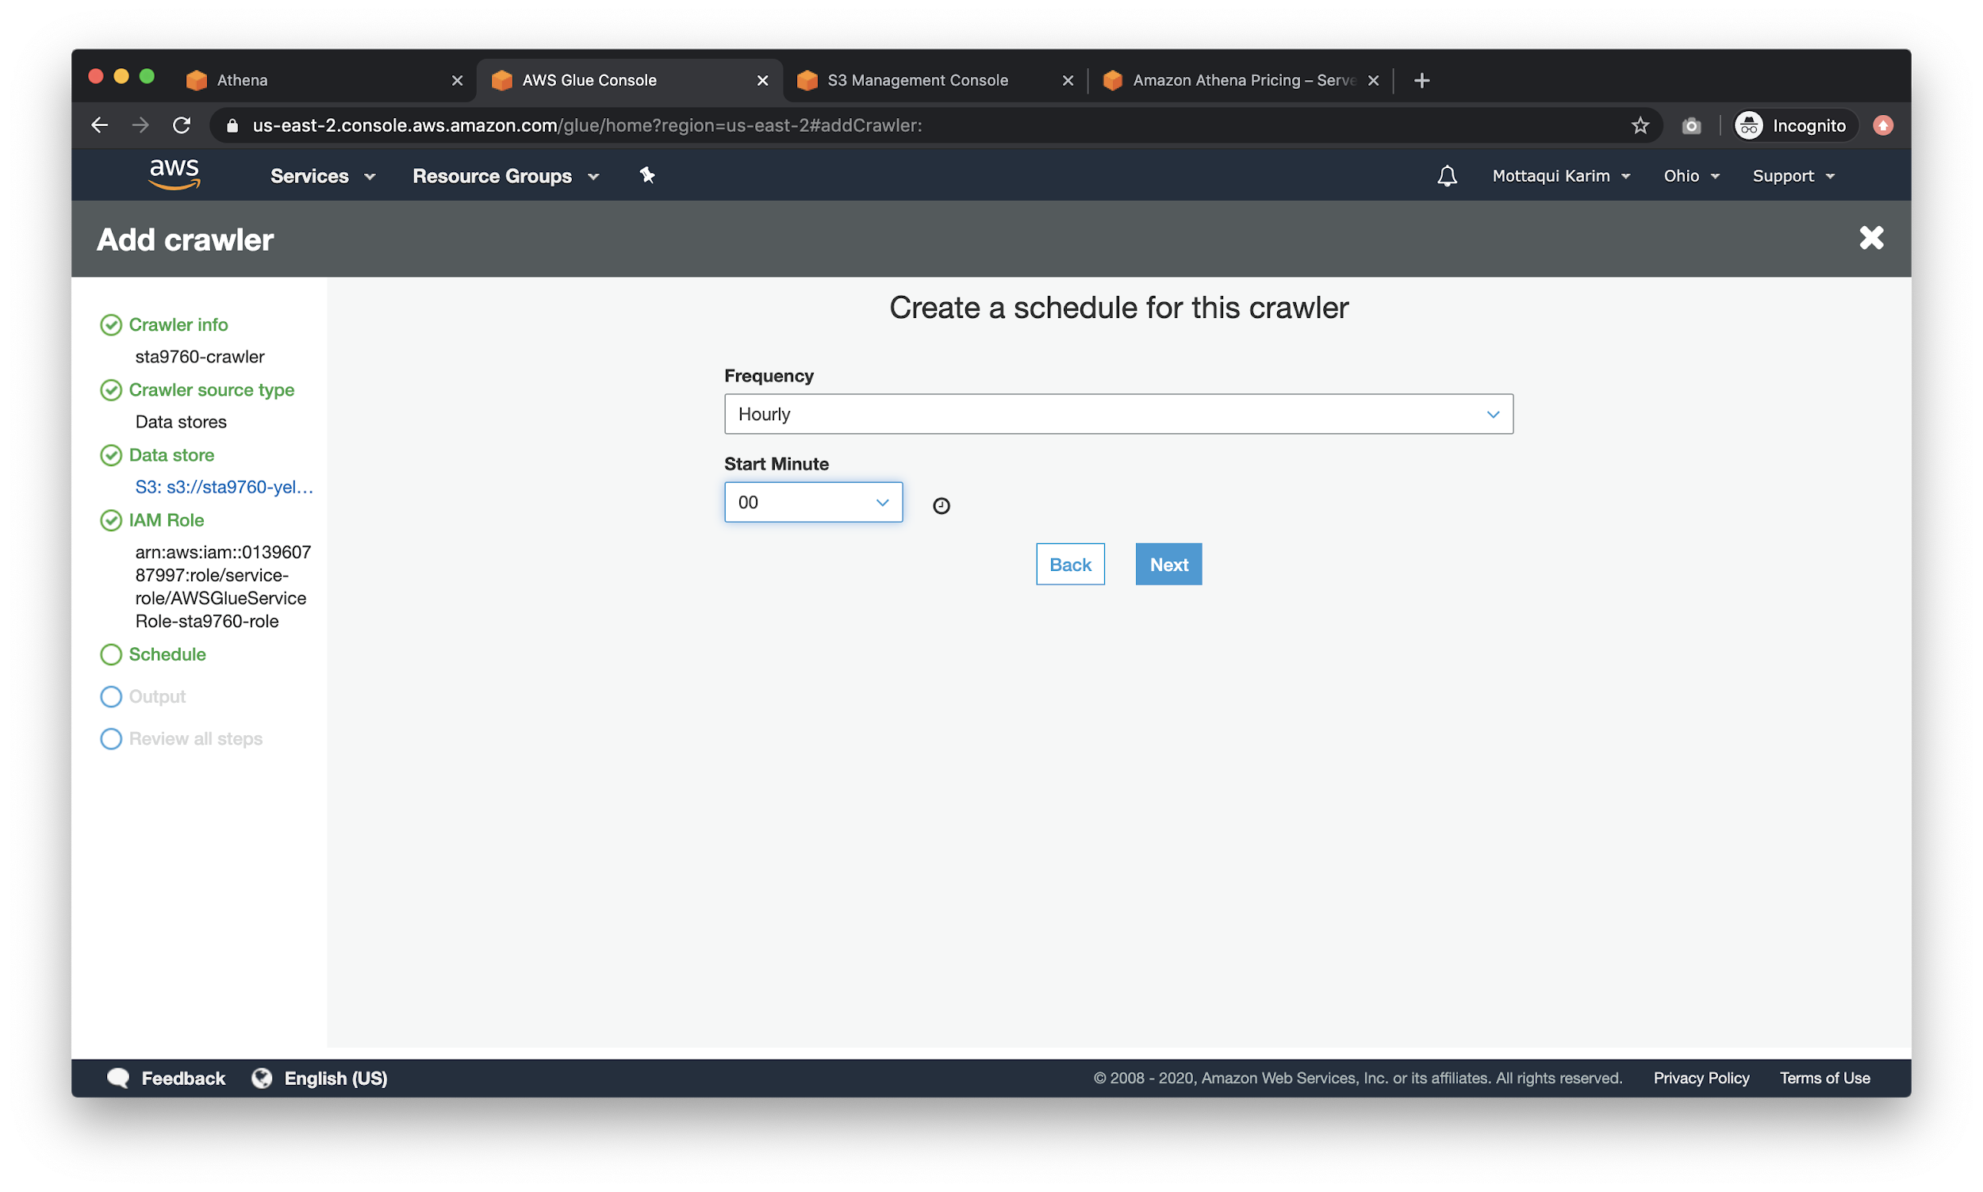

In the next screen, click on the **Add database** button to create a new db for our tables.

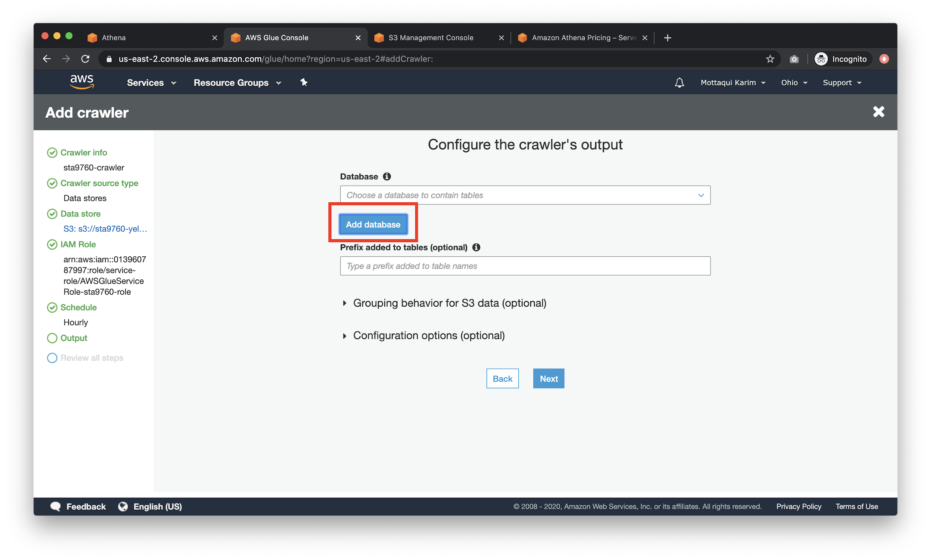

Call your db anything you want, just remember no spaces or punctuation

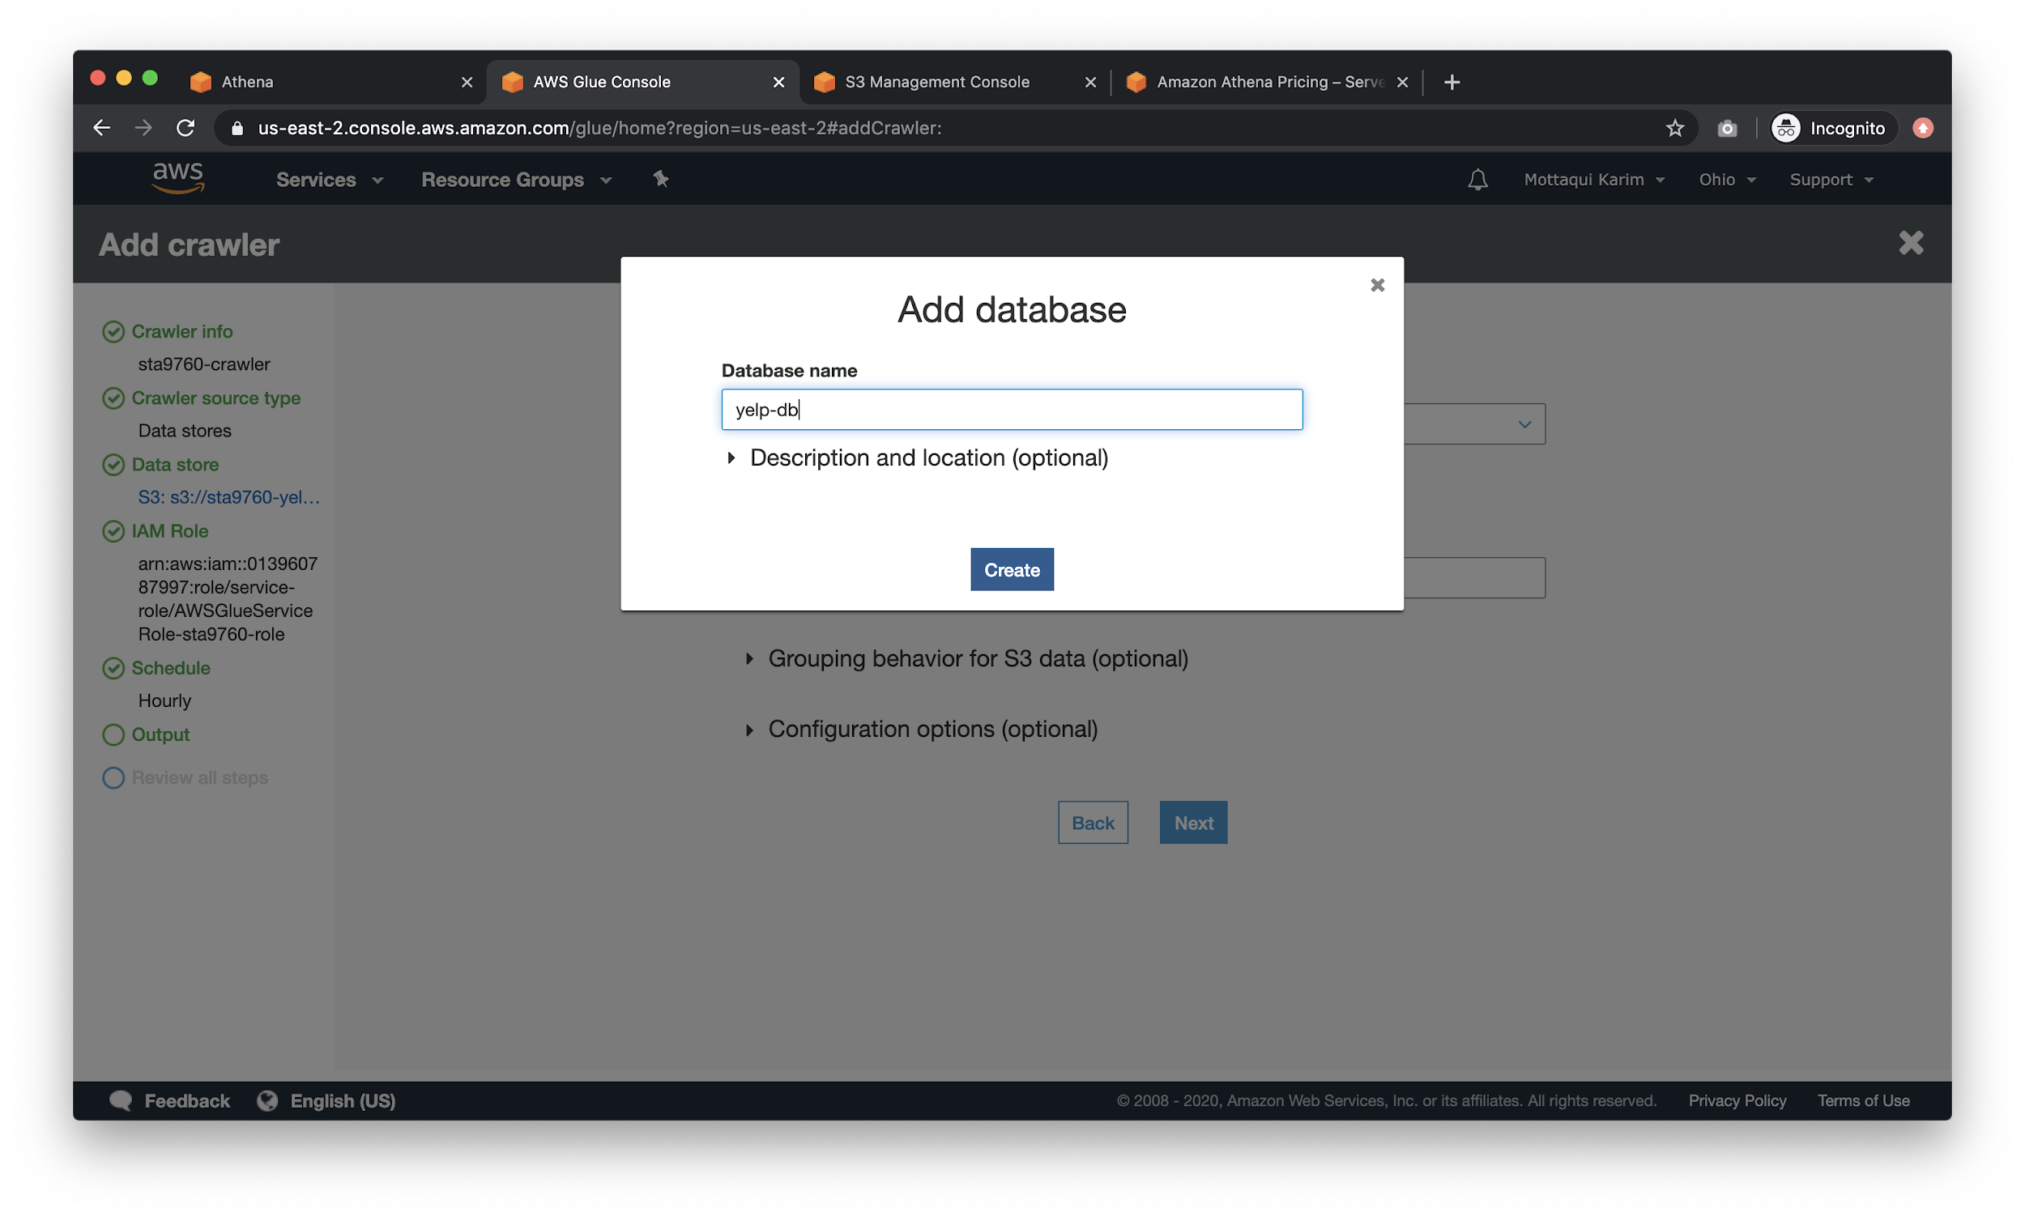

After clicking **Create**, click on the **Grouping behavior for S3 data** option and choose **Create a single schema for each S3 path**.

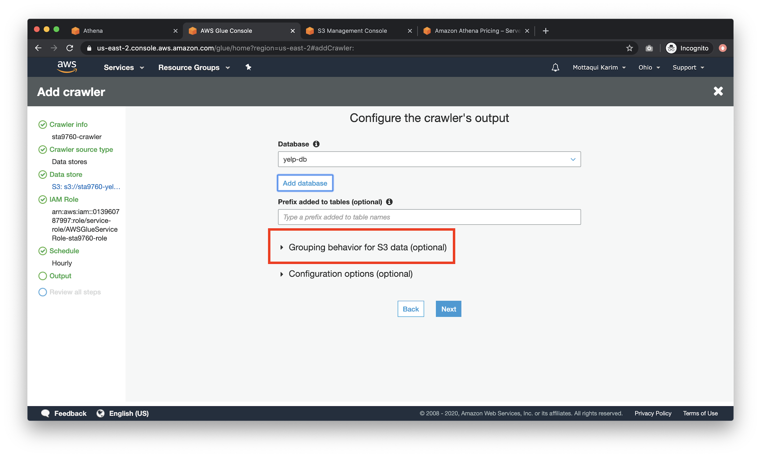

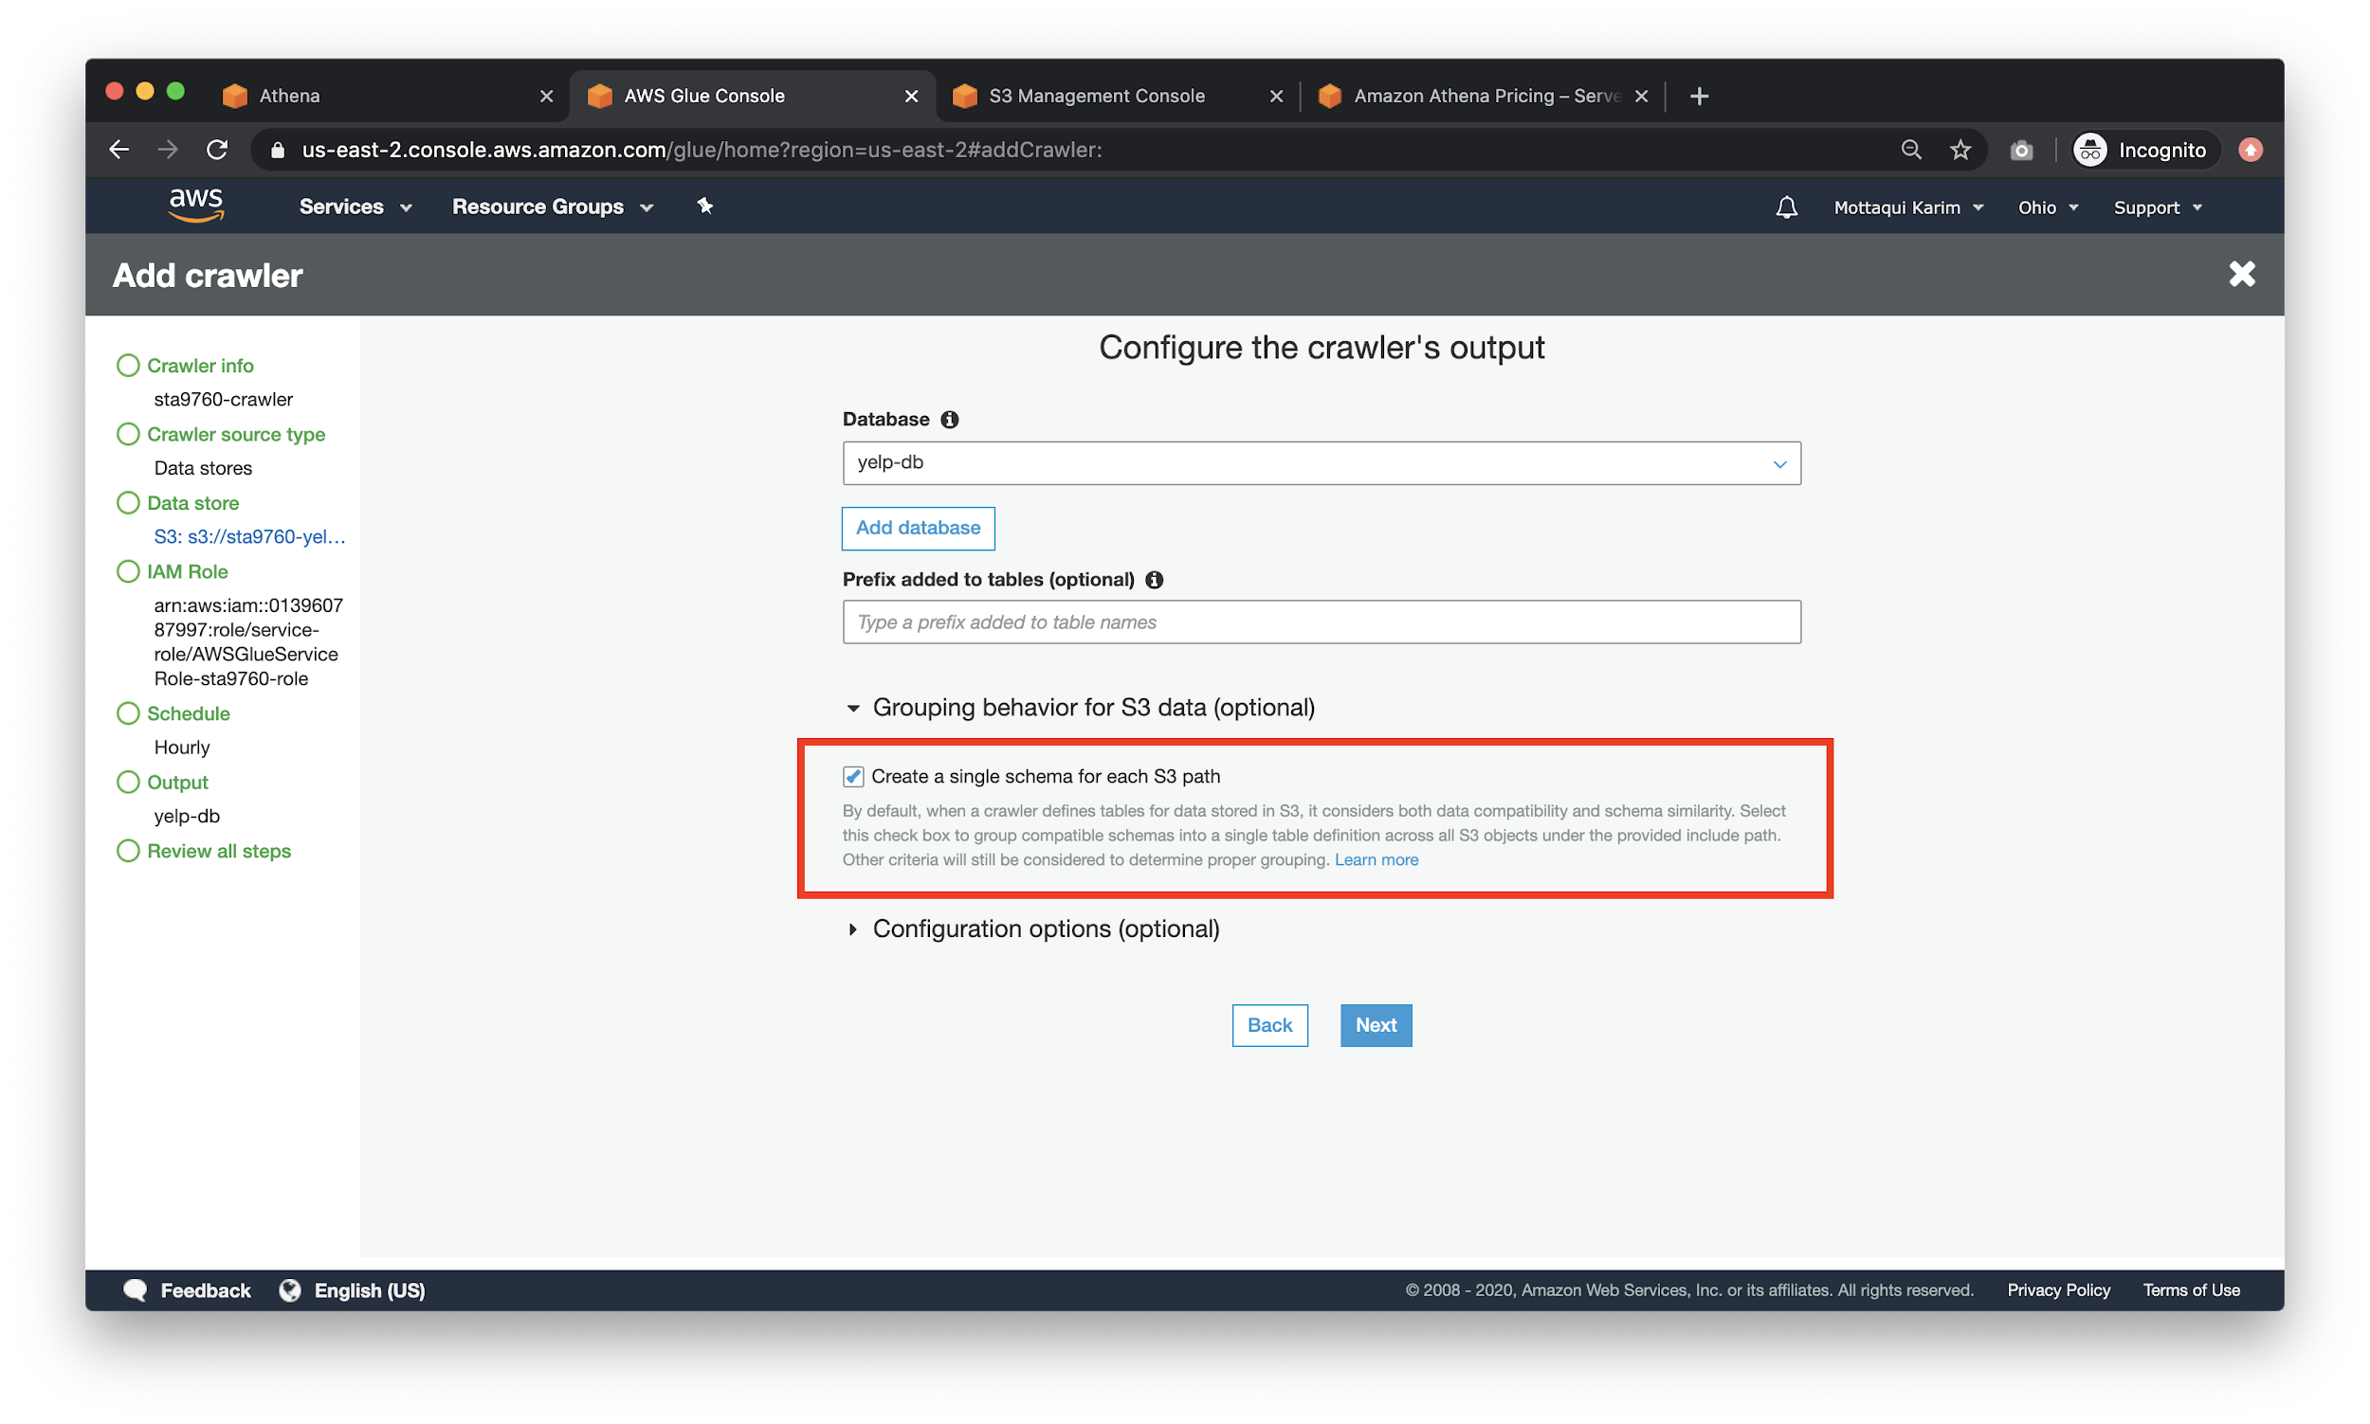

For the last screen, ensure all of your input data is accurate.

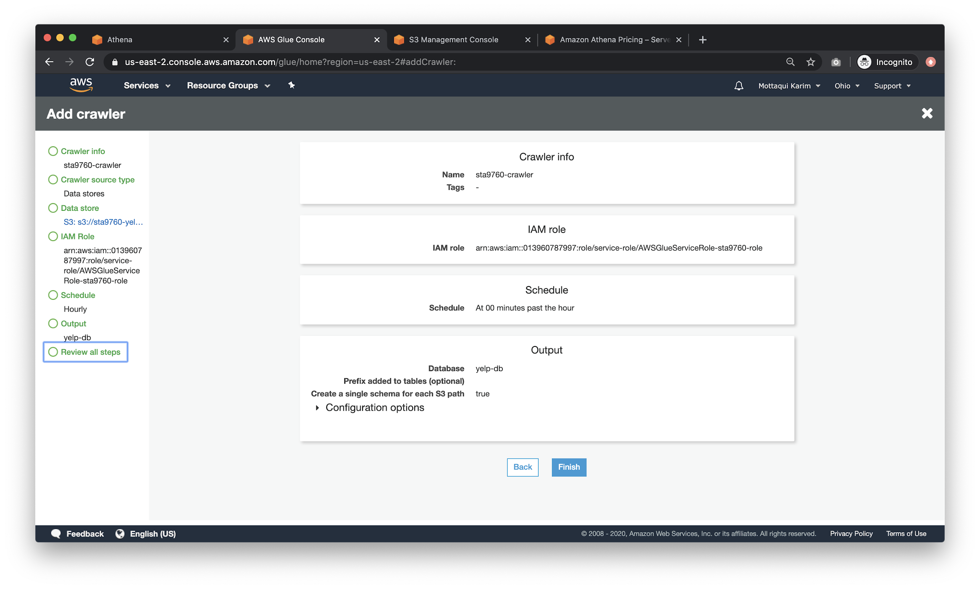

After hitting the **Finish** button and creating your crawler, click on the **Run Crawler** button:

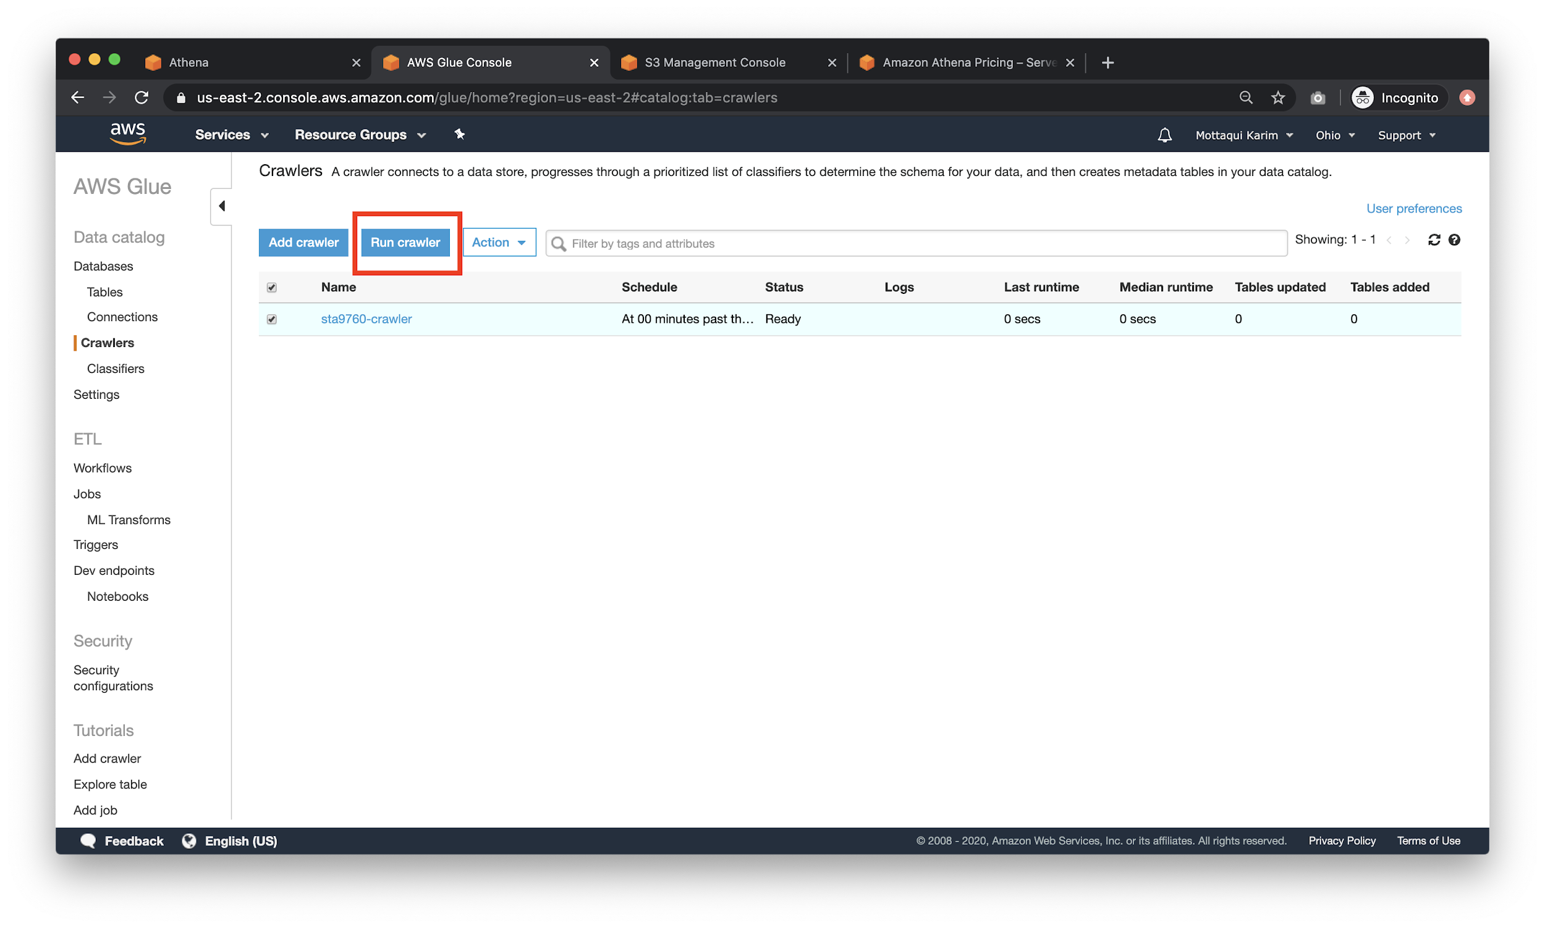

It’ll take a while for the crawling to complete, but eventually, you should expect to see something like:

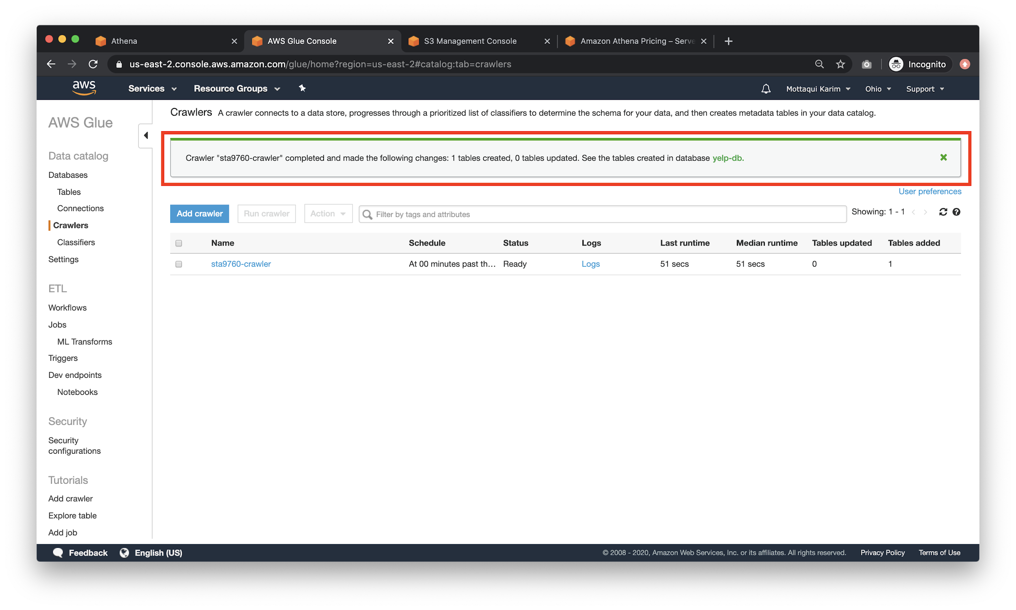

Click into your crawler to view the table:

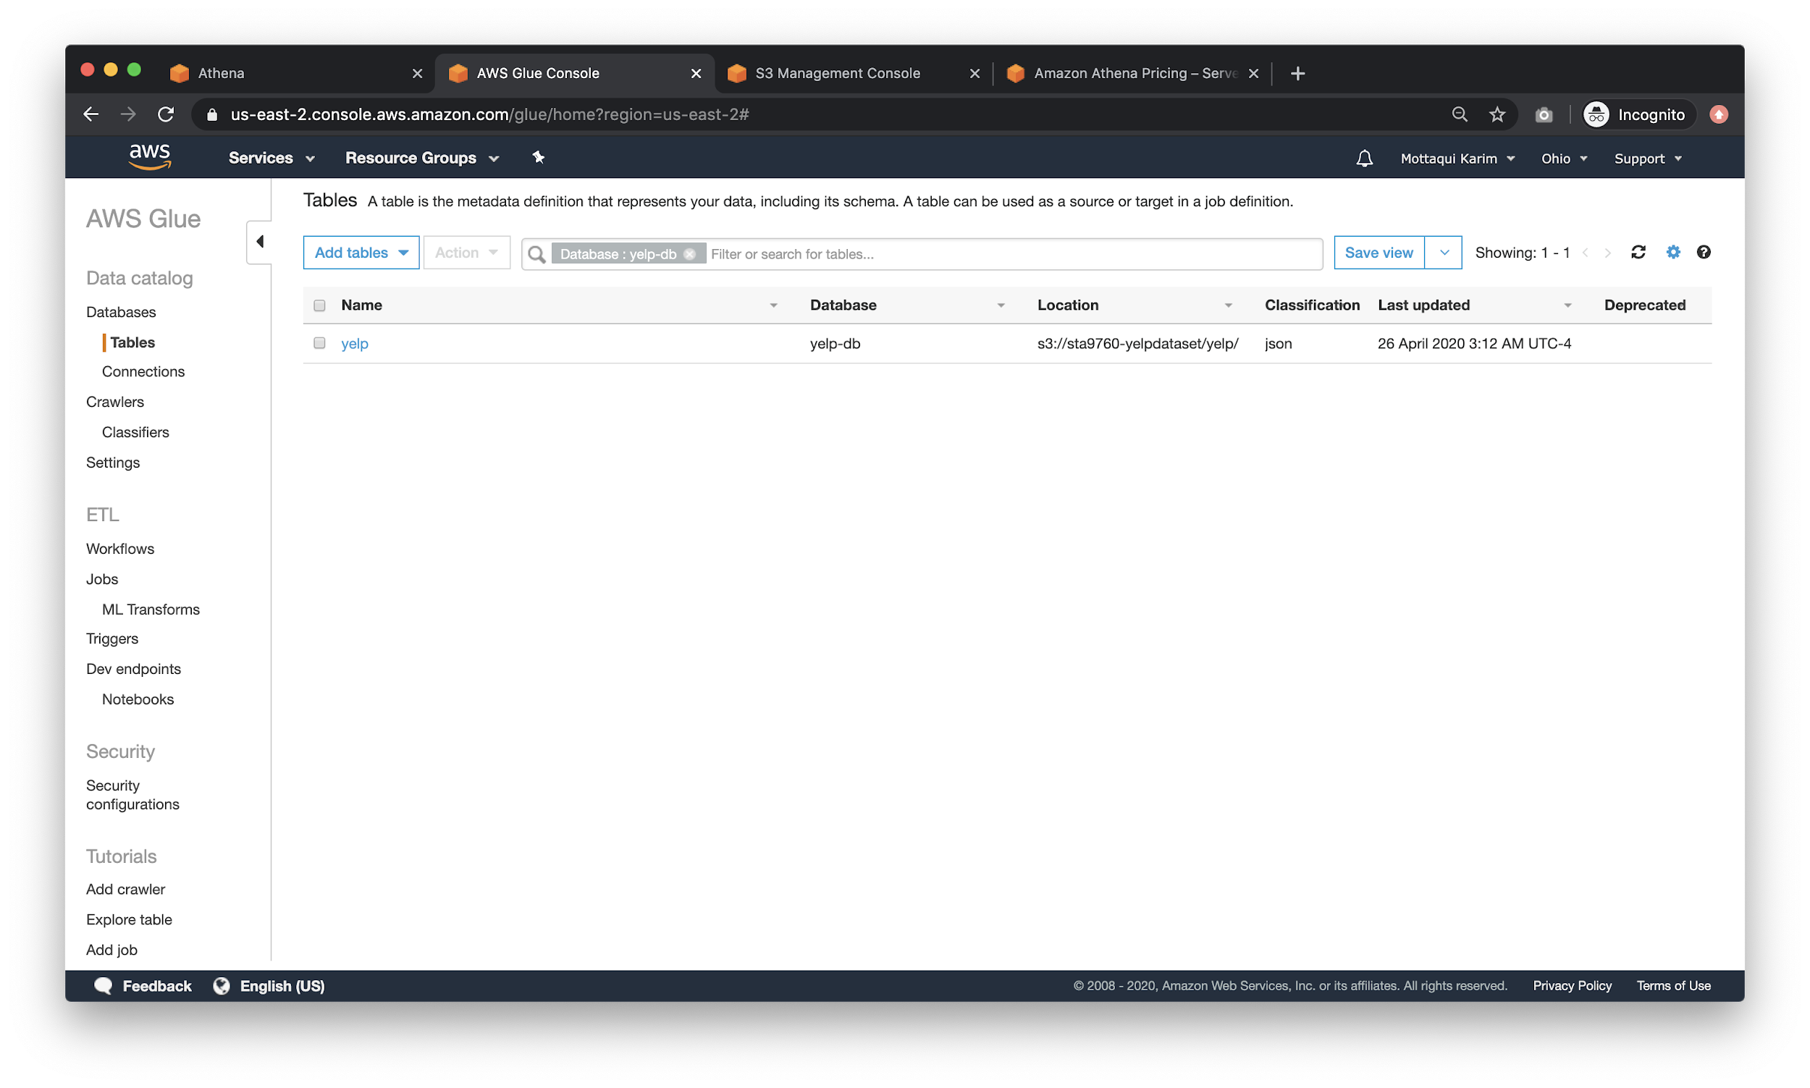

Click into the table to view the schema:

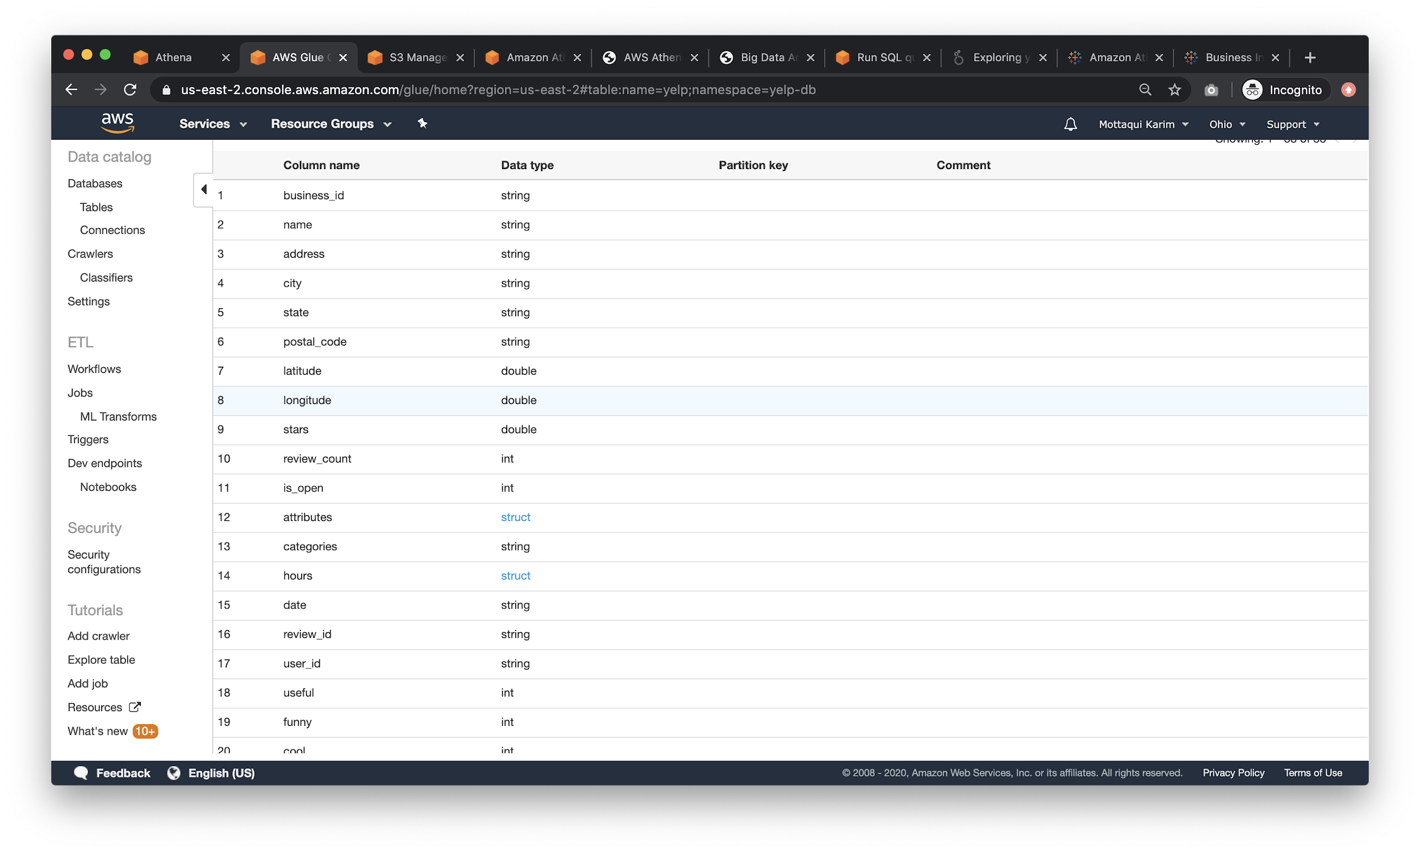

**Now**, go back to the **Athena** page, select **yelp-db** (if that is what you called your database on glue) on the top left and write the following, simple query:

|  |
| --- |
| **SELECT** business_id **FROM** yelp **LIMIT** 10; |

There are a few important elements to notice here:

* **Top Left**: notice how we selected our **db** here. Without this, the query will not work as Athena will not know which “db” to look for table schemas against.
* **Middle**: The runtime and data scanned - data scanned is important because it counts towards your **$5/1TB** pricing model
* **Right:** If you want, you can download a CSV of the query results.

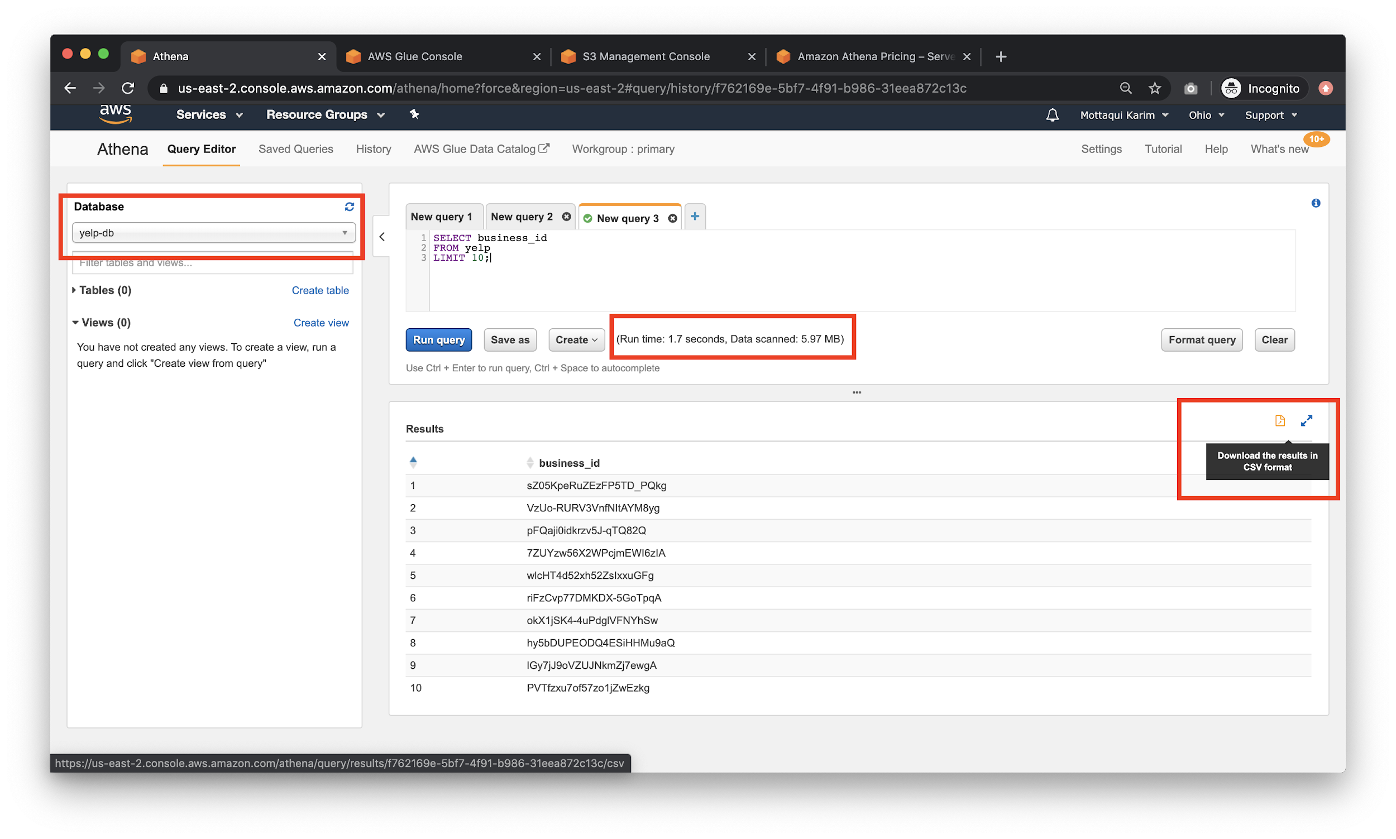

What would happen if we got rid of the **LIMIT 10**?

|  |
| --- |
| **SELECT** business_id **FROM** yelp |

Notice that the run time of the query increased to 12s and that the data scanned figure increased significantly.

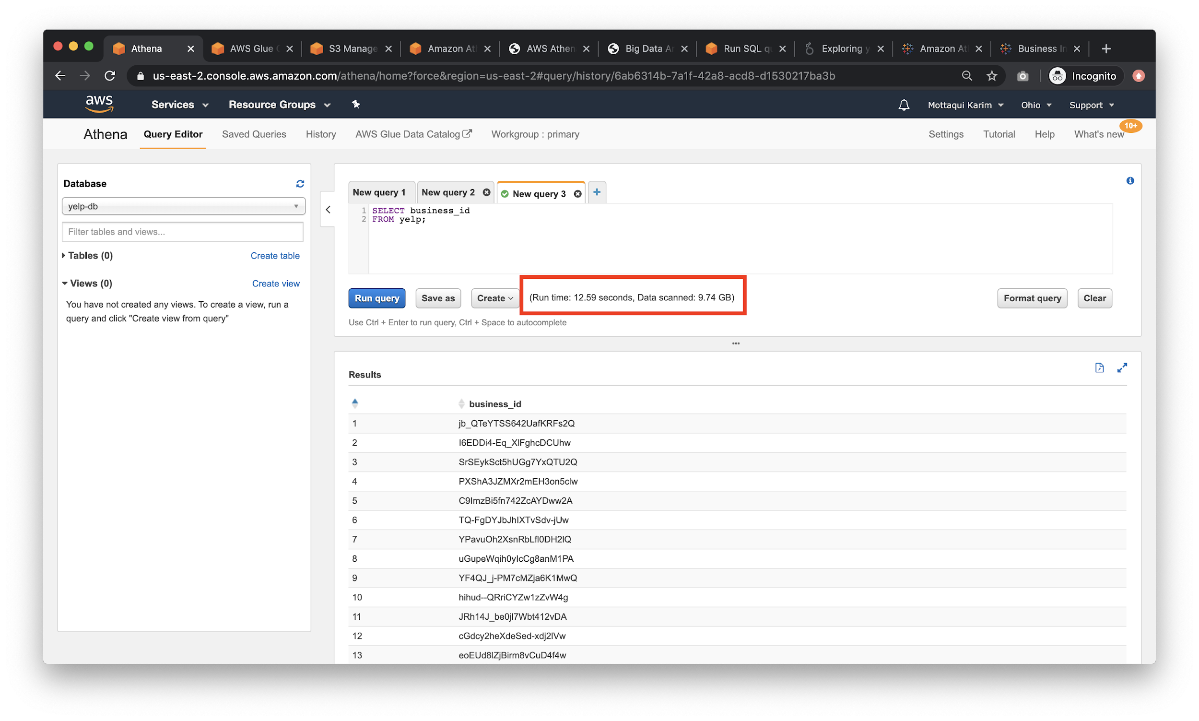

Note that **9.74 GB** is 0.00974th or 0.974% of **1 TB**. This query cost you **4 cents**. If we get a bit more fancy:

|  |
| --- |
| **SELECT** state, **COUNT** (*) **as** num_states **FROM** yelp **GROUP** **BY** state **ORDER** **BY** num_states **DESC** **LIMIT** 10; |

This query *also* costs us **4 cents** despite being more complicated.

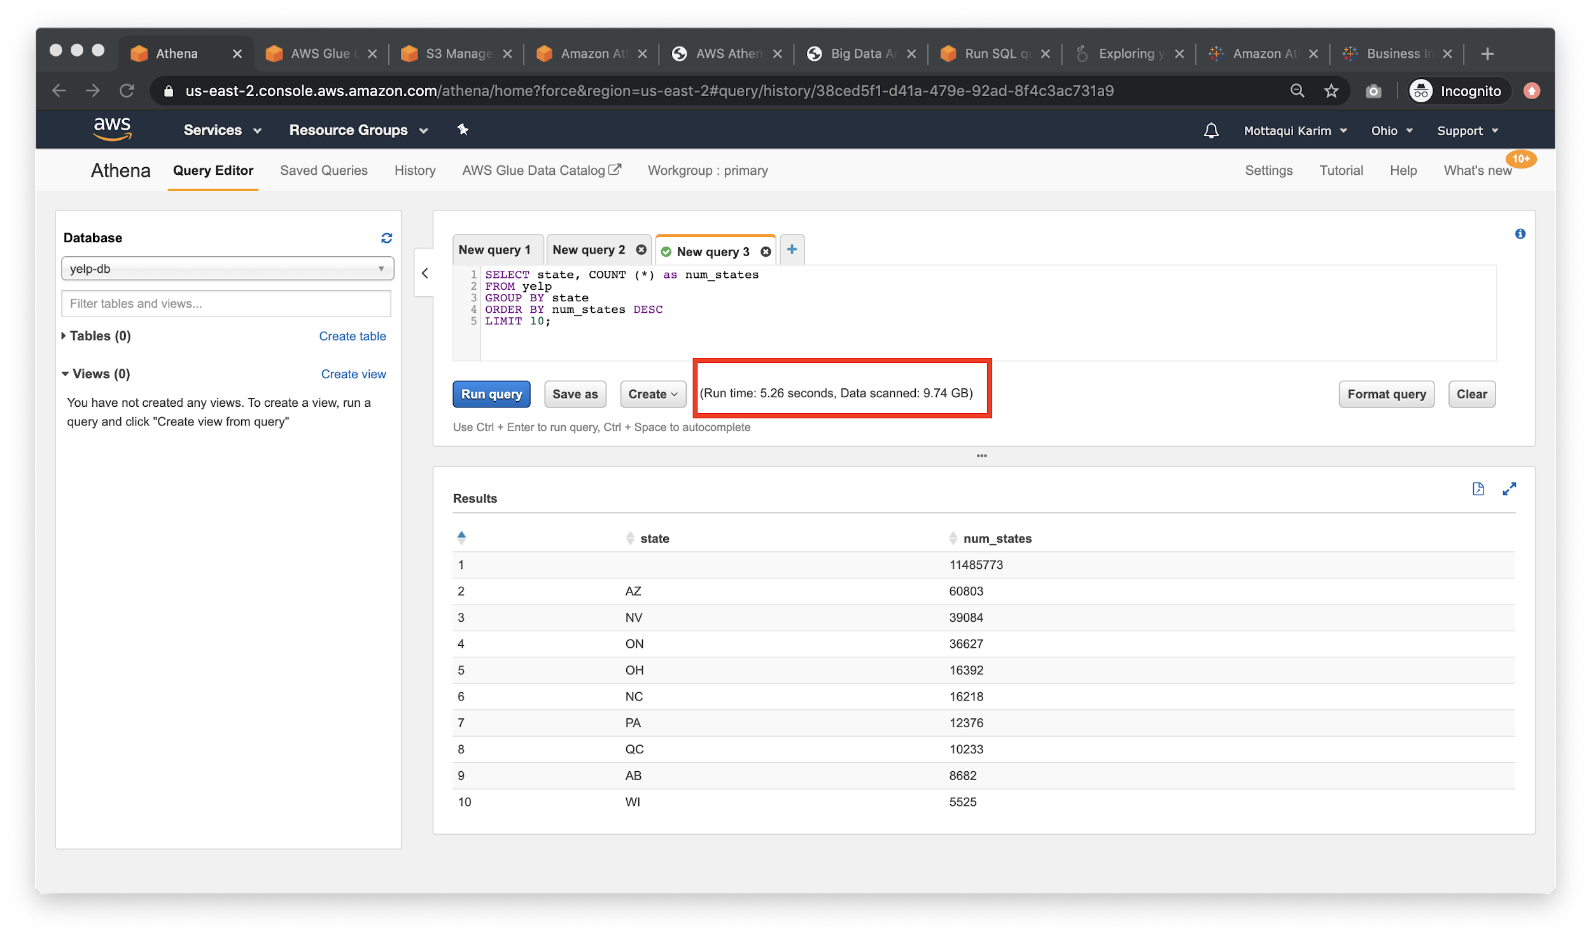

Generally speaking, the size of your dataset is your constraining factor when it comes to cost. There are several strategies for mitigating cost - the two simplest ones being:

* Store data in columnar format - parquet is especially good for this
* Leverage [partitioning](https://docs.aws.amazon.com/glue/latest/dg/aws-glue-programming-etl-partitions.html) whenever possible. For instance, partition your S3 buckets by date or hour and then run queries per “hour” shards - which will decrease the overall size of the data scanned, saving cost.